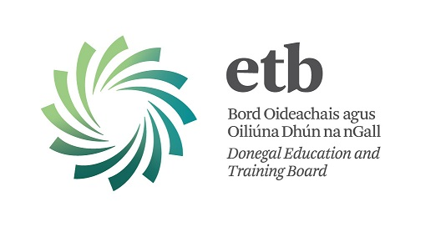

Local Youth Club Equipment Scheme 2017

This scheme is now open.

Information and Application Forms available at: Web: www.donegaletb.ie

Closing date: Friday 20th October 2017

The Department of Children and Youth Affairs has approved the establishment of a once-off equipment scheme for local Youth Clubs/Groups. The scheme is an extension of the Local Youth Club Grant Scheme and has been established in recognition of the important role of volunteer-led youth clubs and groups in supporting young people and in respect of their engagement with the incorporation of the National Quality Standards for Volunteer-led Youth Groups in 2017.

Under the scheme, grants will be made available for the purchase of electrical, sporting, IT, musical, storage and other equipment.

The Local Youth Club Equipment Scheme supports voluntary youth club activity at local level, with priority given to clubs catering for young people between the ages of 10 and 21. Funding for the scheme is provided by the Department of Children and Youth Affairs and is part funded by the proceeds of the National Lottery.

For further information please contact the ETB Youth Officer.

(Youth Officer contact details on the Donegal ETB website)

