Bord Oideachais agus Oiliúna Dhún na nGall
Donegal Education and Training Board


Dear Supplier,

Donegal ETB currently make payments to Suppliers, Staff and Members of the Committee and Sub- Committees by Electronic Funds Transfer (EFT) and Payable Orders.

Under the Public Service Reform Plan and The Public Service Agreement (Croke Park), Donegal ETB intends to make all payments due with effect from 1st May 2013 by means of Electronic Funds Transfer (EFT).

Please Note: A ROI Bank Account is required for EFT payment.
Failure to supply the required information below will result in payments being withheld pending receipt of the information requested below.

Therefore, we request that you complete in full and return the ELECTRONIC FUNDS AUTHORISATION below to:
Donegal ETB Offices, Ard O’Donnell, Letterkenny, Co Donegal

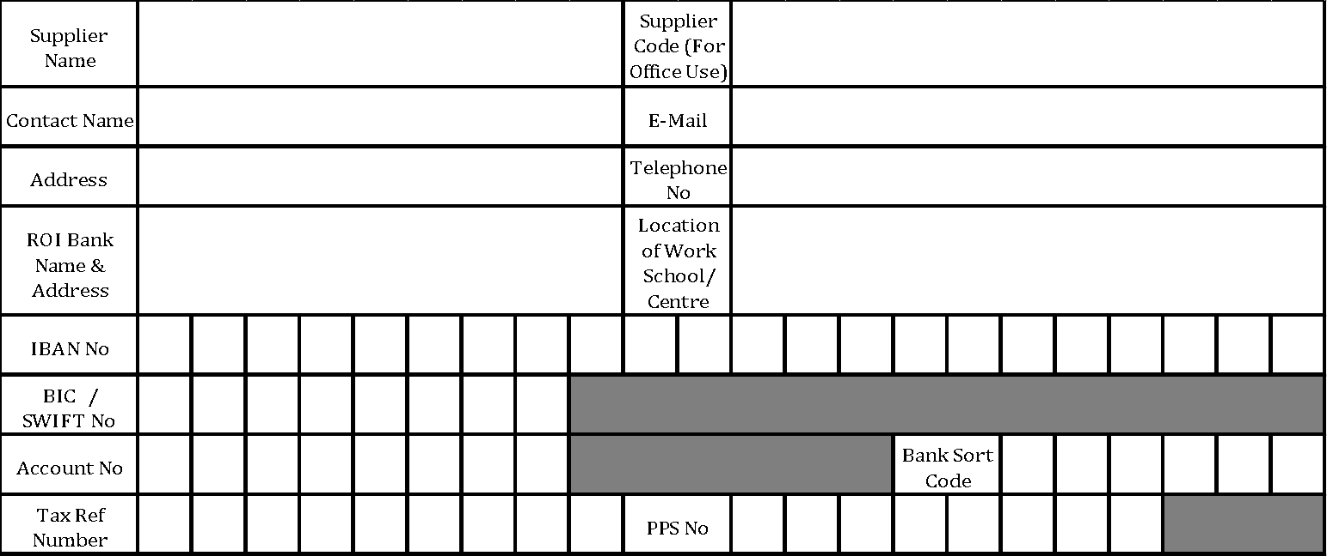

I hereby authorise Donegal ETB to lodge all payments due to this Company / Supplier, to the account details supplied herewith. I undertake to repay any payment(s) lodged to this Bank Account, to which I am not rightfully entitled. I declare that all information supplied by me in relation to the above is both true and accurate.

Signature_________________________ Position _____________________ Date __________

