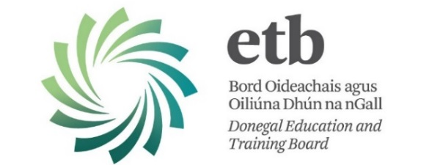
Vacancy

Donegal Adult Learner Guidance and Information Service

Donegal Education and Training Board invites applications from suitably qualified candidates for the
following post:

Adult Guidance Counsellor (Acting) – Donegal Town

The Position
The Donegal Adult Learner Guidance Service is an established service under the Adult Education Guidance Initiative providing client centred educational and vocational guidance to adult learners participating in the adult education programmes of Donegal Education and Training Board and self-referring clients from the general public.

Due to a career break, we have a vacancy for an Adult Guidance Counsellor to deliver guidance services. This post will be based in Donegal Town with some outreach work.

The Person
We are seeking a highly committed guidance counsellor to deliver an innovative and creative programme of information, advice, guidance and counselling to our client base. Applicants should possess excellent communication and interpersonal skills, experience in adult/further education and training, teaching, employment service, youthwork, community development or social science, a competence in the Irish language (desirable), a primary degree and one of the following postgraduate guidance qualifications:

• A Post Graduate Diploma in Careers Guidance or Careers Guidance and Counselling, or
• A Masters of Education (Guidance), or
• A Master of Science in Counselling, or
• Equivalent post graduate qualification recognised by the Irish Association of Counsellors and Psychotherapists or the Institute of Guidance Counsellors.

The applicant should also possess a full driving licence and access to a car. Appointment is on a one year specified purpose basis, subject to qualifications reckonable for recognition as teaching qualifications as per Teaching Council Registration.

Appointment with immediate effect and it is anticipated that interviews will be held week commencing 13th March, 2017

Salary
€ 41,474 - € 59,390
€ 37,327 - € 59,390 (new entrants)

The closing date for return of completed application forms is
12:00 noon on Monday 20th February, 2017

Please note:
- Completed application forms will not be accepted via e-mail.
- Shortlisting of applicants may take place.
- Late applications will not be considered.

Contact Details:
Marie Donnelly
Phone: 074 91 61551
Email: mariedonnelly@donegaletb.ie

