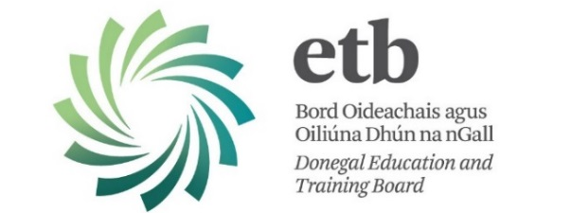

Vacancy

Donegal Education and Training Board invites applications from suitably qualified candidates for the following post:

Co-ordinator
Adult Learner Guidance and Information Service

The Adult Learner Guidance and Information Service offers impartial and confidential information, advice, guidance and counselling on the educational options that are available to clients both within Donegal ETB and with other education providers.

The aim of the service is to support clients to make the right decisions about returning to education and training and to help them make those decisions within the context of their wider lives.

Qualifications and Experience
The ideal candidate will hold one of the following:-

- A post graduate diploma in Careers Guidance or Careers Guidance and Counselling or,
- A Masters of Education (Guidance) or,
- A Master of Science in Counselling,
or
- equivalent post graduate qualification recognised by the Irish Association of Counsellors and Therapists or the Institute of Guidance Counsellors.

Experience in the field of education or training, youth work, community development or social science, or a teaching qualification as specified under Memo V7 and/or Circular 32/92, is also desirable.

Other relevant experience may include teaching, education/training experience in adult or youth work or employment services.

Salary
Remuneration is in accordance with the salary scale determined by the Department of Education and Skills, €37,327 - €59,390. New Entrants are placed at the first point of scale.

The closing date for return of completed application forms is
12:00 noon on Wednesday, 7th December, 2016.

Please note:
- Completed application forms will not be accepted via e-mail.
- Shortlisting of applicants may take place.
- Late applications will not be considered.

Contact Details:
Linda Harley, Human Resources Division, Donegal ETB.
T: (074) 9161510 E-mail: linda@donegaletb.ie

