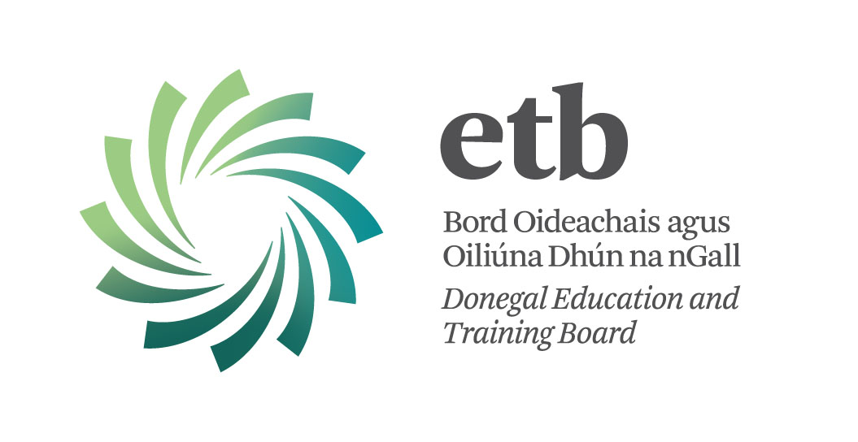

The above Board invites applications from suitably qualified persons who wish to be considered for the following tutor panel in respect of part-time tutor vacancies that may arise in 2017/2018:

Further Education and Training

Tutor Panel
(Basic Education and Literacy)

Subject Areas:
• Information and Communications Technology (ICT)
• Mathematics
• Gaeilge
• English, including ESOL
• Communications
• Personal Effectiveness and Career Preparation
• Customer Service and Retail Skills
• Family Learning

Locations:
Tuition takes place at ETB Adult Education and Training Centres and on an outreach basis throughout Co. Donegal.

Remuneration:
Remuneration is at specific hourly rates, determined by Donegal ETB in accordance with Department of Education & Skills / SOLAS regulations.

Further Information:
Please refer to the information booklet

Closing date for receipt of completed applications is 12:00 noon on Friday, 17th November 2017.

Late applications will not be considered. Shortlisting of candidates may take place.

