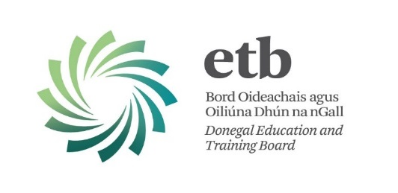
PERSON SPECIFICATION

Post: Community Education Facilitator
Location: Donegal ETB
Capacity: Half Time Post [18.5 hours]
Ref: FET/CEF/17

 | ESSENTIAL
QUALIFICATIONS / EXPERIENCE | Candidates should have:-  - a third level qualification of at least National Certificate standard in the field of education, training, youthwork, community development or social science.  or  - have obtained a teaching qualification, and  - Have at least three (3) years work experience in a relevant field.  Candidates without the required third level qualification will also be considered, if they have a minimum of five (5) years’ experience working in adult or community education, training, youthwork or community development, but they will be required to obtain the qualification within five (5) years of appointment.  Ability to work through the medium of Irish
SKILLS | Have the requisite knowledge, skills and competencies to carry out the role.
COMPETENCIES | - Team Leadership  - Interpersonal and Communication Skills  - Analysis and Decision Making  - Management and Delivery of Results  - Specialist Knowledge, Expertise and Self  Development  - Drive & Commitment

