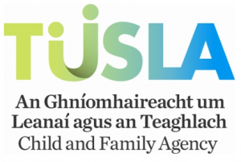

The Local Management Committee of Raphoe School Completion Programme Cluster Group (The Employer) invites applications for the following post:

Post: SCHOOL COMPLETION PROGRAMME (SCP) CO-ORDINATOR
Location Deele College, Raphoe, Co. Donegal
Capacity: Fixed Term
Employer: Raphoe, SCP – Local Management Committee
REF: SCP/RCG/17

The Position:
This is a fixed term post for an initial period of one year, which may be extended subject to continuous funding by TUSLA, the Child and Family Agency and satisfactory service in the post.

The SCP Co-ordinator will work as part of a team within the Raphoe SCP Cluster Group providing support for students in school, after school and during holiday time and in the out of school setting.

Conditions and Terms of Employment are in accordance with the Local Management Committee of Raphoe SCP Cluster Group/TUSLA/Department of Education and Skills
Salary Scale: €37,207 - €61,648.

To Apply:
Further details including a list of the Raphoe Cluster Schools, Application Form, Job Description & Person Specification are available on the Vacancies Section of www.donegaletb.ie

Closing date for receipt of completed applications is 12 noon on Monday, 28th August, 2017

Please note:
- Completed applications by post to Linda Harley, Donegal ETB, Ard O’Donnell, Letterkenny, Co. Donegal.
- Late applications will not be accepted.
- Shortlisting of applicants may take place.
- It is intended to hold interviews for this post in the week commencing 11th September, 2017.
- The successful applicant will be subject to satisfactory Garda Vetting and Reference Checks prior to taking up duty.
- The post holder will be expected to take up duty on Monday, 2nd October, 2017.
- Queries can be addressed by email to: recrutiment@donegaletb.ie.


Funded by the Department of Education and Skills under the National Development Plan with assistance from the European Social Fund

