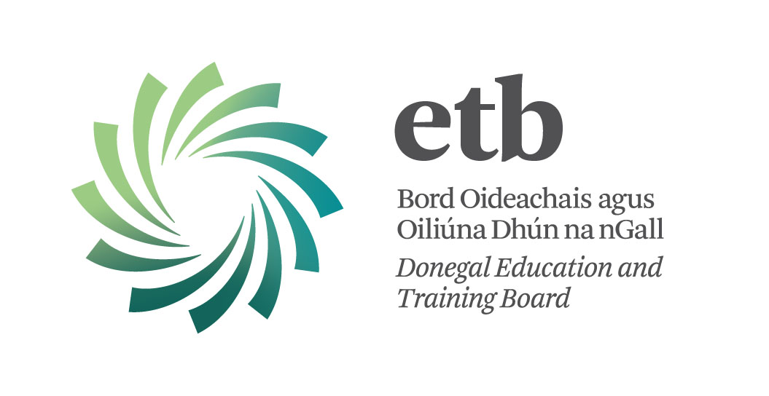

Special Needs Assistants

Irish is essential for this post

Donegal ETB invites applications from suitably qualified Persons for post which may arise as Special Needs Assistant for the 2017/18 school session as follows:

POST: SPECIAL NEEDS ASSISTANT– 1 X 32 HR POST
LOCATION: COLÁISTE CHINEAL EOGHAIN, BUNCRANA
CAPACITY: FIXED TERM
REF DS/SNA/CCE/17

Special Needs Assistants are recruited specifically to assist students with disabilities in an educational context.

Priority may be given to members of the Supplementary Assignment Panel since 1st May, 2014 who may apply (See CL 42/17 on Department of Education and Skills website www.education.ie).

These posts are subject to satisfactory Garda Vetting and reference checks.

Closing date: 12:00 noon on Wednesday 16th August, 2017

Please note as per Section 20 of CL 42/17 in relation to recruitment that “This is subject to the SNA meeting any specific competencies and/or requirements to meet the special educational needs of the pupil(s).”

Pacaiste Iarratais Gaeilge
Tá leagan Gaeilge den foirmeacha do Shonraíocht an Phoist/Sonraí faoin bPearsa agus an Fhoirm Iarratais seo ar fáil ach teagmháil a dhéanamh leis and Roinn Acmhainní Daonna:
Fón : 074 91 61535
Ríomhphost: recruitment@donegaletb.ie

Contact Details:
Sandra Mc Connell
Human Resources Division
Donegal ETB, Administrative Offices, Ard O’Donnell, Letterkenny, Co. Donegal
T: (074) 9161600 E: recruitment@donegaletb.ie

Donegal ETB is an equal opportunities employer.

