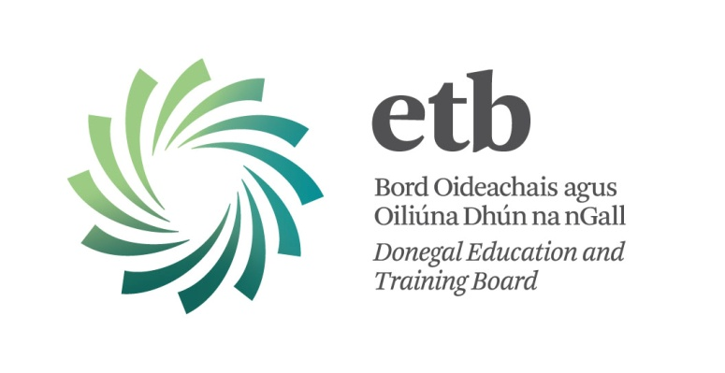

Post as Deputy Principal - Job Description

Errigal College

Reporting to the Chief Executive and to Donegal Education and Training Board

Functional Relationships:-

- Staff, Parents and Students – Partners in Education
- Chief Executive and Administrative Staff of Donegal ETB
- Board of Management of Errigal College
- Department of Education and Skills
- Other outside agencies e.g. NEPS, National Education Welfare Board, Special Education Council, HSE, Department of Social and Family Affairs etc.
- The wider community

Key Functions:-

1. To be responsible under the Chief Executive for the organization, discipline and administration of Errigal College.

Specific Tasks:-
The specific tasks involved will vary from time to time and will include but not
be limited to the following:-

1. The Deputy Principal will support:-
- the development and provision of appropriate learning and curricular programmes to meet the needs of all students in the school
- the implementation and monitoring of staff performance appraisal and professional development
- the identification of the staffing needs of the school i.e. teaching and ancillary
- the control management and direction of both the teaching and ancillary staff allocations to the school
- the control and allocation of the school’s financial resources and the maintenance of up to-date financial records and reporting systems
- to establish and maintain a system to handle organizational tasks such as student records, teacher records, attendance, purchasing procedures and timetables
- to ensure the security of the school building and safe keeping of property
- the development and maintenance of effective relationships with the stakeholders involved inclusive of the Education and Training Board and its agents and staff, the Board of Management, Staff, Students, Parents, Parents Association, Student Body, Student Council and the schools community.
- to assist and advise the Board of Management/ETB/CE with the development of strategic and annual plans
- to assist and advise the Board of Management on policy, professional, financial and administrative matters
- to implement the policies and decisions of the Education and Training Board, the Board of Management, the Minister and the Department of Education and Skills
- to comply with all relevant statutes and regulations

2. To engage in teaching the number of hours per session specified as per the regulations of the Department of Education and Skills.
3. To comply with the lawful orders of the Education and Training Board and its Chief Executive and with the rules and requirements of the Minister for Education & Skills.

Post as Deputy Principal – Person Specification

Errigal College

Essential Skills and Qualities:-

The Deputy Principal should:-

- have the ability to lead effectively within a team environment
- have the ability to communicate effectively in writing and orally with staff, students, parents and the overall school
- have the ability to work with all staff to create an effective staff development plan for all employees in the school
- have the ability to create and maintain a climate of respect and fairness for all staff and students
- have the ability to establish a method of shared decision making agreed upon by all stake holders involving a particular internal management team
- have the ability to create and maintain a safe orderly positive and effective learning and working environment
- exhibit and promote multi-cultural awareness, gender sensitivity and racial and ethnic appreciation
- have the ability to make informed objective judgments
- have the ability to employ, monitor and maintain acceptable accounting procedures in the maintenance of all fiscal records
- demonstrate up to-date teaching competence and excellence
- show commitment to continuous and ongoing personal professional development.

