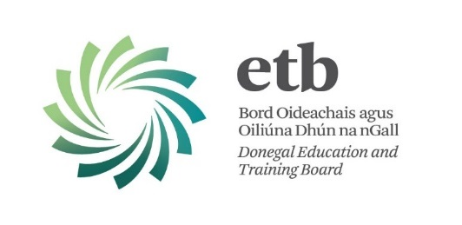
PERSON SPECIFICATION

Post: Development Officer
Capacity: Fixed Term (one year)
Location: ETB Training Centre, Ballyraine, Letterkenny
Ref: FET/DO/LTC/17

 | ESSENTIAL
QUALIFICATIONS / EXPERIENCE | Have a qualification at Level 8 on the National Framework of Qualifications or its equivalent, and/or significant relevant work experience.  Third level qualification(s) in relevant discipline(s) commensurate with this role would be a decided advantage.
SKILLS | - A high level of knowledge and expertise in the area of Further Education and Training, and in particular of Quality Assurance systems.  - A broad Public Sector knowledge relevant to this area of work.  - Good oral and written communication skills.  - Good ICT and administration skills.  - Willingness to work flexible hours outside of normal office hours.  - Full driving licence and access to a car.  Competencies will be informed by best practice Public Appointment Service Competency Framework for the Irish Public Service.
COMPETENCIES | - Leadership Potential  - Interpersonal and Communication Skills  - Analysis and Decision Making  - Management and Delivery of Results  - Specialist Knowledge, Expertise and Self  Development  - Drive & Commitment to Public Service Values

