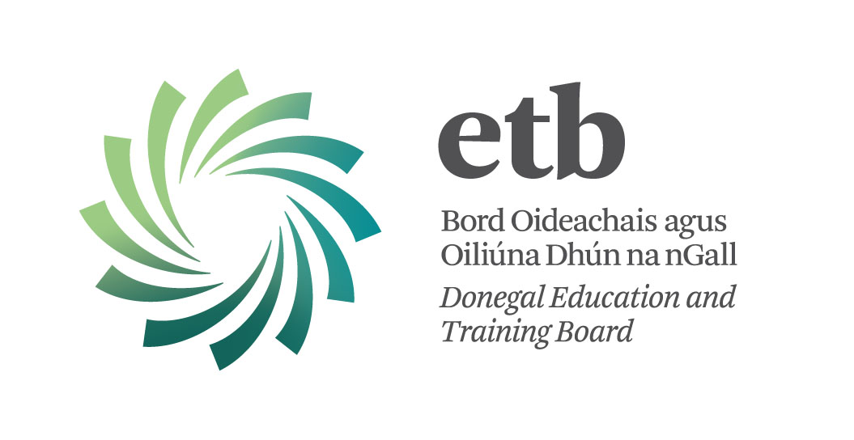

School Bus Escort

Donegal ETB invites applications from suitably qualified Persons for post which may arise as School Bus Escort for the 2017/18 school session as follows:

POST: SCHOOL BUS ESCORT (1)
LOCATION: PETTIGO TO WILLOWBRIDGE SPECIAL
SCHOOL, ENNISKILLEN, CO FERMANAGH
CAPACITY: SPECIFIC PURPOSE
REF DS/BE/WSS/17

Morning Pick Up 8.15 am - Drop Off 9.30 am
Afternoon Pick Up 2.15 pm - Drop Off 4.15 pm

This School Bus Escort Post is for the one to one supervision of a young child. Bus Escorts are expected to supervise pupils with Special Educational Needs whilst they are being transported from home to school and vice versa.

Preference will be given to candidates who have experience in working with children with Special Educational Needs and be able to deal with parents and school staff and bus staff in a professional way.

This post is subject to satisfactory Garda Vetting and reference checks.

Closing date: 12:00 noon on Wednesday 9th August, 2017

Please Note:
Willowbridge Special School is not under the aegis of Donegal ETB. Donegal ETB are facilitating recruitment of this School Bus Escort on behalf of the Department of Education and Skills

Pacaiste Iarratais Gaeilge
Tá leagan Gaeilge den foirmeacha do Shonraíocht an Phoist/Sonraí faoin bPearsa agus an Fhoirm Iarratais seo ar fáil ach teagmháil a dhéanamh leis and Roinn Acmhainní Daonna:
Fón : 074 91 61535
Ríomhphost: recruitment@donegaletb.ie

Contact Details:
Sandra Mc Connell
Human Resources Division
Donegal ETB, Administrative Offices, Ard O’Donnell, Letterkenny, Co. Donegal
T: (074) 9161600 E: recruitment@donegaletb.ie

Donegal ETB is an equal opportunities employer.

