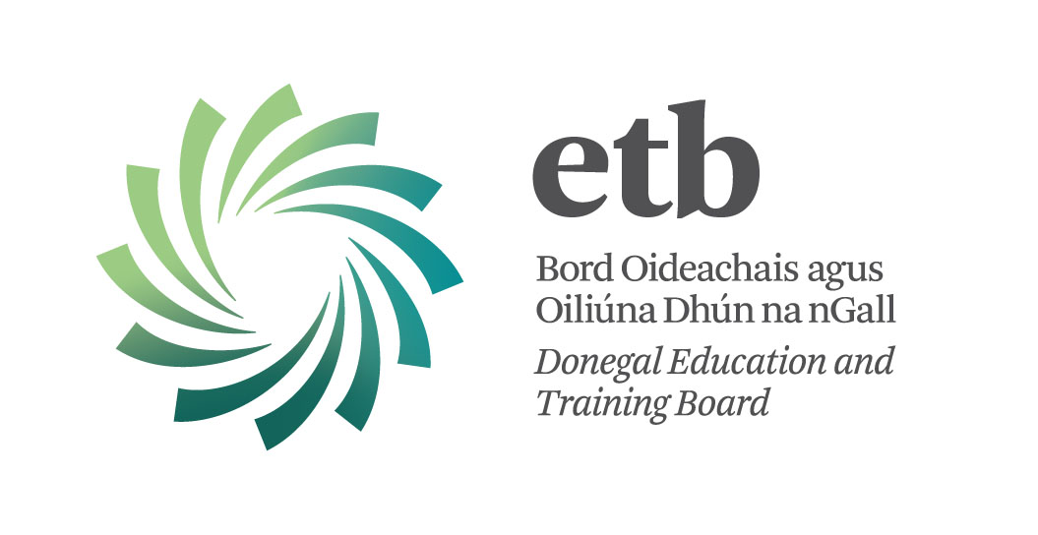

Special Needs Assistants

Priority may be given to members of the Supplementary Assignment Panel since 1st May, 2014 may apply (See CL 35/16 on Department of Education and Skills website www.education.ie).

Donegal ETB invites applications from suitably qualified Persons for posts which may arise as Special Needs Assistants for the 2016/17 school session as follows:

St Catherine’s Vocational School, Killybegs: 1 whole time post (32hrs) – REF: SNA 6

Special Needs Assistants are recruited specifically to assist students with disabilities in an educational context.

Qualifications:
With effect from 1st September 2011, the minimum required standard of education for appointment to the post of Special Needs Assistant is:-
1. A FETAC level 3 major qualification on the National Framework of Qualifications, OR
2. A minimum of three grade Ds in the Junior Certificate, OR Equivalent
AND
FETAC Level 5 Certification in Childcare or related field of study is essential. Successful candidates must hold 8 modules as specified by FETAC for the purposes of certification for Childcare Level 5 award.

Please note as per Section 20 of CL 35/16 in relation to recruitment that “This is subject to the SNA meeting any specific competencies and/or requirements to meet the special educational needs of the pupil(s).”

Hours: 32 hrs per week (whole-time) or 16 hrs per week (half time)
Salary: New Entrants after 1/1/2011 – 1st point €13.11 per hour to 15th point €22.36 per hour
Employed before 1/1/2011 – 1st point €14.23 per hour to 15th point €22.36 per hour

Application forms and further details :-
(i) may be downloaded from Donegal ETB Website www.donegaletb.ie
(ii) on request by e-mail at: sandra@donegaletb.ie

The closing date for receipt of completed application forms is:
12:00 noon on Wednesday 31st August, 2016.

Please Note:
- Shortlisting of applicants will take place.
- Completed application forms will not be accepted via e-mail.
- Late applications will not be considered.

Contact Details:
Sandra Mc Connell
Human Resources Division
Donegal ETB, Administrative Offices, Ard O’Donnell, Letterkenny, Co. Donegal
T: (074) 9161600 E: sandra@donegaletb.ie

Donegal ETB is an equal opportunities employer.

