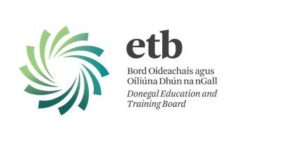

​EXECUTIVE SELF-EVALUATION REPORT
Executive Self-Evaluation Report for Donegal ETB​

22nd December 2017
Donegal ETB
Administrative Offices
Ard O’Donnell
Letterkenny
Co. Donegal
F92 DP98
Phone 074 9161600
info@donegaletb.ie
www.donegaletb.ie
Signed:
Anne McHugh, Chief Executive, Donegal ETB.

Table of Contents
1: Introduction, Purpose and Objectives 4
2: Donegal ETB Profile 4
Figure 1 FET Centres 5
Table 2: Scope and Range of FET Provision within Donegal ETB 5
2.2 QQI Awards and Programmes and Analysis: 6
Figure 2. (QQI Infographics 2016) 7
2.3 Other Awarding Bodies 7
Table 2: Other Awarding Bodies and Quality Assurance agreements in place within ETB 8
2.4 Strategic Focus of Donegal ETB’s Further Education and Training Service 9
2.4.1 Integration of Adult & Further Education service and Training service 9
2.4.2 Preparing for Integration 9
2.4.3 Progressing Integration: examples from the Donegal ETB experience 9
2.4.4 Community and Employer Engagement 10
2.4.5 Learner-centred 11
3: Executive Self-Evaluation Process and Timeline 12
4: Governance, Planning and Management of Quality 13
4.1 Current Governance Model 13
Figure 4: FET Staffing and Governance Structure 2017 13
Table 3: Stakeholder and Working Groups 14
4.2 Evaluation of Governance under QQI Core and Sector Specific Guidelines 15
Figure 5: Proposed new Governance Structure 16
4.3 Governance Planned Actions 17
5: Delivery of FET 18
5.1 Programme Design, Delivery and Review 18
5.1.1 Work-based learning 18
5.1.2 Themed and integrated programmes 18
5.2 Programme Design, Development, Delivery and Review 19
Figure 6: Programme Development Cycle 20
5.3 Teaching and Learning 20
5.3.1 Materials and Resources 20
5.3.2 Continuous Professional Development 21
5.4 Teaching and Learning Planned Action 21
5.5 Technology Enhanced Learning 21
5.6 Teaching and Learning Planned Action-TEL 22
5.7 Consistency of Assessment 22
5.8 Assessment Planned Actions 23
5.9 Assessment Integrity Security and Information 23
5.10 Assessment Appeals 24
5.11 Drafting 25
5.12 Reasonable Accommodation in Assessment 25
5: 13 Results Approval 26
5.14 Assessment Integrity Planned actions 26
5.15 Public Information and Communication 27
5.16 Public Information Planned Actions 27
5.17 Staff Recruitment 27
6: Learner Recognition and the Learner Experience 28
6.1 Learner Admissions 29
6.1.1 Learner induction to both the provider and the programme. 29
6.1.2 Processes and tools to collect information 29
6.1.3 Fair recognition of education and training qualifications, periods of study and prior learning. 29
6.2 Learner Admission Planned actions 30
6.3 Learner Experience and Learner Supports 30
6.4 Learner Experience Planned actions 31
7: Information and Data Management 32
7.1 Information and Data planned actions 32
8. Collaborations and Stakeholder Relationships 33
8.1 Evaluation of Collaboration and Planned Actions 35
9. Apprenticeships/Traineeships & Work Based Learning 36
9.1 Apprenticeships 36
9.2 Traineeships 36
9.3 Skills for Work 37
9.4 Learner Work Experience and Work Practice Assessment 37
9.5 Planned Actions Work Based Learning 37
10: Conclusions, Planned Actions and Quality Improvement Plan (QIP) 38
Appendix 1 41

1: Introduction, Purpose and Objectives
This document constitutes the Executive Self Evaluation (ESE) for Donegal Education and Training Board. The ESE was conducted in line with the QQI Statutory Core Quality Assurance and Sector Specific Quality assurance guidelines for Education and Training Boards and within nationally agreed terms of reference. See Appendix 1.
The ESE describes positive initiatives that have taken place since the formation of the ETB to help improve on our Quality Assurance policies and procedures. In developing the ESE, we have also been self-critical in outlining areas for improvement and enhancement that have regard to the expectations set out in the QQI Core Statutory and Sector specific guidelines. Along with creating critical dialogue in the re-engagement process with QQI and making an impact in satisfying the QQI guidelines, the document also helps focus FET management and staff in their attempts to achieve “Excellence in the delivery of a quality learner-centred education and training service”, Donegal ETB’s overall mission statement.

2: Donegal ETB Profile
Donegal ETB was established under the Education and Training Boards Act 2013. Following ministerial approval, the Donegal ETB was officially established. The ETB is the amalgamation of the former Donegal VEC with the former FÁS service which was delivered through two training centres and an outreach contracted training programme. The integration of the two training centres into the Donegal ETB took place in July 2014.

Donegal ETB’s further education and training provision includes a range of programmes from levels 1-6 on the NFQ, as well as other third-party awarding body programmes certified by industry or, alternatively, vendor-based certification. The ETB also offers unaccredited training in the community through its family learning programmes (Literacy) and funding of community groups to facilitate greater social inclusion under the KEATS framework in the PLSS (Programme Learner and Support System) programme and course scheduling database.
This FET provision is delivered by approximately 330 fulltime and part time staff in 14 FET centres and 3 Schools which deliver PLC courses, and in outreach locations throughout our community and second provider provision. Learners are supported by services that include an Adult Guidance Service, administrative services in Head Office, and in the community-based FET Centres/outreach locations.

Figure 1 FET Centres
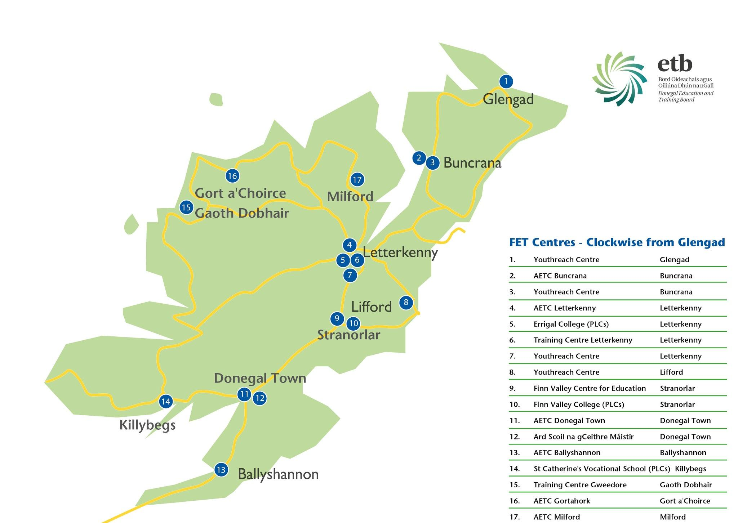

Table 2: Scope and Range of FET Provision within Donegal ETB
2016/2017 (PLSS Learner Data and Apprenticeship System)
Apprenticeship Training Phase 2 | 158
Adult Literacy | 1,465
Bridging and Foundation Training | 58
BTEI (Back to Education Initiative) | 700
Community Education | 4,586
ESOL | 436
Evening Training | 627
ITABE | 82
Local Training Initiatives | 38
PLC (Post Leaving Certificate) | 353
Sills for Work | 157
Specialist Training Providers | 90
Specific Skills Training | 677
Traineeship Training | 347
VTOS (Vocational Training Opportunities Scheme) | 176
Youthreach | 292

Along with the above operational FET programmes there are a number of support services and working groups that are helping to enhance the learner experience and support for the programmes.
These include:
- The Information, Recruitment and Guidance Service
- The Enterprise Engagement Group
- The FET Co-ordinators Group
- The Quality Assurance Working Group

The ETB also offers an education service to its schools through the Donegal Music Education Partnership and Outdoor Training and Education through Gartan Outdoor Education and Training Centre. A full time Youth officer is also based within the ETB while outreach education services are provided also in the North West through a community addictions studies officer located in the ETB administrative offices in Ard O’Donnell, Letterkenny.

2.2 QQI Awards and Programmes and Analysis:
The ETB’s FET Service is currently offering programmes that lead to awards at NFQ levels 2-6 by QQI to learners. These awards were requested through 22 different QQI requesting centres in 2016.
In 2016, Donegal ETB conferred 4,939 QQI awards from levels 2-6 on the NFQ. 3,985 of these awards were component awards with ‘Listening and Speaking at level 2 accounting for 216 of these. The highest award count in 2016 was for General Learning-Programme P2GLO of which 106 compound awards were conferred. 327 Major awards at level 5 were conferred with Healthcare Support 5M4339 accounting for 64 of these and 98 major awards were conferred in Early Childhood Care and Education 5M2009. Of the 138 awards delivered at level 6 by the ETB in 2016, 37 of these were Special Purpose awards in Training and Development 6S3372. 12 Major awards at Level 6 were conferred in Early Childhood Care and Supervision 6M2007.

Figure 2. (QQI Infographics 2016)
http://infographics.qqi.ie/Provider/Details/PJ00022
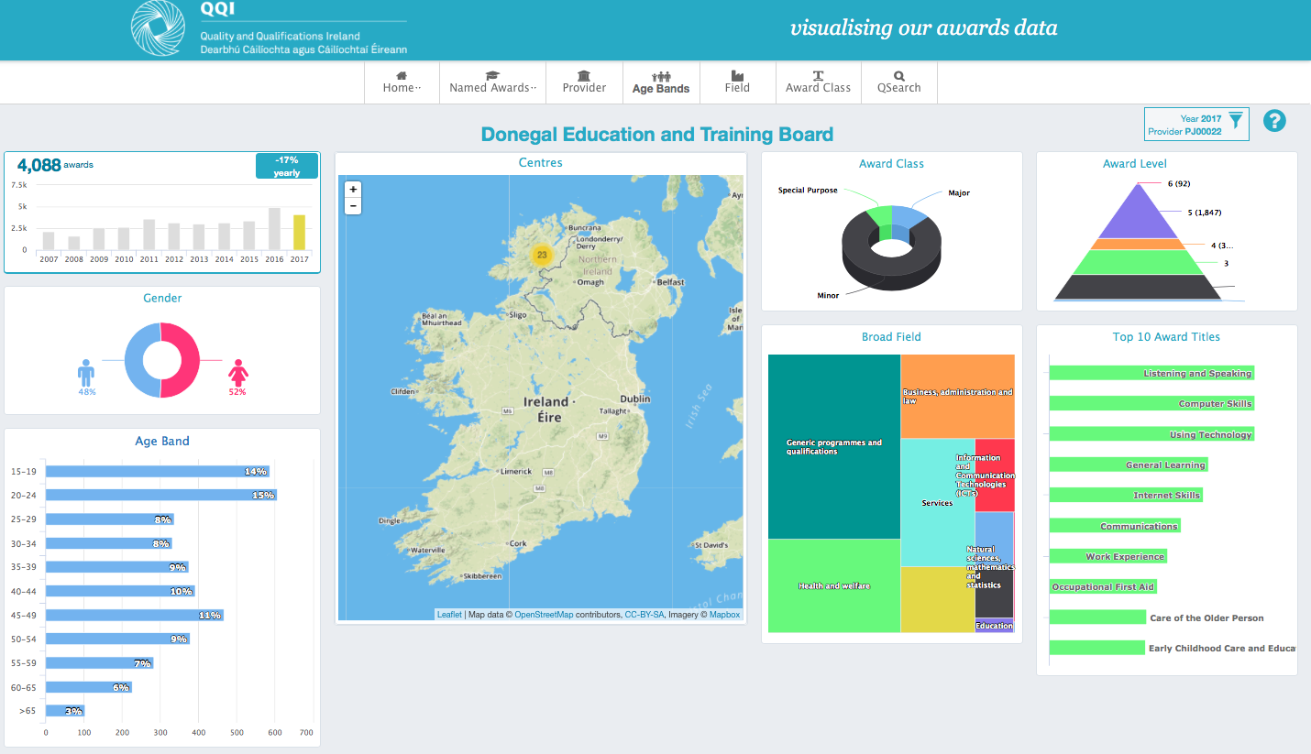

2.3 Other Awarding Bodies
Along with QQI certification, Donegal ETB is also an approved provider of City & Guilds Qualifications in ICT, Software Development, Food and Beverage and Culinary Arts and Social Media and Marketing for Business. In 2017, a former ETB learner was awarded a prestigious City & Guilds Lion award at a ceremony in England for her work in Information Technology and Software Testing. The Centres also have approval to deliver ITEC/VTCT qualifications in a range of Beauty Therapy qualifications.
Donegal ETB has 6 ECDL testing centres, of which the training services centre offers consolidated testing for both in centre and outreach locations coordinated through the Training Standards office.
Along with these other awarding bodies, the ETB offers vendor-based certification for industry awards in Information Technology as well as certifying welders to EN standards.
IT vendor certification Includes Microsoft, Oracle, CompTia, ISTQB Software Testing and ITIL Project management. Much of the accredited IT vendor based certification is recognised by the IT industry. The ETB is fortunate to be able to test both ETB learners and members of the public in the Pearson Vue Testing centre based at the Letterkenny Training centre. This testing facility helps to cater for the demand for both employees upskilling along with e-college learners wanting to test in the region. It is complemented by the national agreement with Prodigy Learning allowing for Microsoft Testing in the training centres.

Table 2: Other Awarding Bodies and Quality Assurance agreements in place within ETB
Awarding Body | Qualifications Offered | QA Arrangements in Place
City & Guilds | 7574 IT Users,  7267 IT Professionals,  7513 Diploma in Digital Marketing. | Qualifications approval  Internal Verification and QA coordinators
ITEC/VTCT | Beauty Specialist Diploma | Qualifications approval  Internal Verification and QA coordinators
ILM-Institute of Leadership and Management | Enterprise  First Line Management | Qualifications approval  Internal Verification and QA coordinators
ECDL | ECDL, Equalskills | ECDL Testers and exam proctors.  ECDL Coordinator
Microsoft | Microsoft Office Specialist, Microsoft Technology Associate | Exam administration and proctoring for Certiport Console 8 Testing System
Adobe | Adobe Certified Associate | Exam administration and proctoring for Certiport Console 8 Testing System

2.4 Strategic Focus of Donegal ETB’s Further Education and Training Service
The following points identify the key areas on which Donegal ETB has placed its strategic focus since its establishment in 2013. Additionally, in November of this year, Donegal Education and Training Board approved the ETB Strategy Statement (2017-2021) Lean ar Aghaidh, following a countywide consultation process that included engagement with all its stakeholders including FET learners, staff and management, as well as community representatives and industry. The three areas of focus within the ETB Strategy Statement are: Teaching and Learning, A Progressive, Accountable Organisation and Working with Partners.

2.4.1 Integration of Adult & Further Education service and Training service
Since the establishment of Donegal ETB and, in particular, since the amalgamation of the former VEC and the former FÁS, there has been a key strategic focus on the integration of the adult and further education service and the training service at local level. This focus was essential if Donegal ETB was to deliver on the objectives of the national FET Strategy (2014-2019) and, in particular, if the ETB was going to be able to deliver a coherent and cohesive offering of educational opportunities to the people of Donegal. The level of integration which has been achieved to date is the result of careful planning, taking small initial steps and being strategic in terms of the structures that were established to deliver the new FET service and the projects that were selected for implementation.

2.4.2 Preparing for Integration
Prior to the amalgamation, staff from both organisations had worked together regularly on projects and committees and so relationships had already been established at programme and middle management levels.
In preparation for the amalgamation, regular meetings took place between both VEC and FÁS management (chaired by VEC CE) and then between VEC Adult Education Service management and Training Services management. It became obvious at an early stage that the different Quality Assurance systems would be a key challenge for both organisations to overcome and a Quality Assurance Working Group was established to begin the sharing of practice and ideas; group membership included VEC Adult Education Officers and Coordinators who had responsibility for QA and the Training Standards Officers and other relevant staff from FÁS. This group has remained in existence and is the key vehicle for progressing the QAG procedures.
A Donegal ETB Website Working Group was also established to revamp the website and to integrate the training services provision. This project turned into a much larger initiative whose eventual outcome was a new website and also the creation of a searchable database of Donegal ETB FET courses which was the template for the national FETCH courses website.

2.4.3 Progressing Integration: examples from the Donegal ETB experience
Shortly after the appointment of the Director of FET in September 2016, a conscious strategic decision was made that the position would be located in the ETB Training Centre in Letterkenny, to send a message to ETB staff that the integration of both services (FE and training) was a key objective. The appointment of one of two new Adult Education Officers (AEOs) in January 2017 who has responsibility for QA within Donegal ETB brought experience from training services and of the TQAS system.
A further strategic decision aimed at further assisting integration was the creation of a middle management group of FET Co-coordinators who meet on a monthly basis; a key focus of this group is to share information across all the FET services and to progress integration of projects and systems where possible.
The FE literacy service has been partially integrated into both training centres to give support to learners (including apprentices) on programmes taking place in the centres. Following an initial phase of building relationships between tutors and instructors, one-to-one and group literacy and numeracy interventions help support learning and prepare learners for assessment. It is worth noting that the literacy/numeracy tutor is located in the training centres as this is seen as key to the success of the initiative. The ability for learners to be able to drop with the tutor after classes has made the service and support accessible and integrated the service within the training centre.
An FET Course Recruitment Officer has been recently appointed. An emphasis has been placed on this individual liaising with the FE adult guidance service, and also taking into account the proposed new national information, guidance and recruitment strategy.
The appointment of a replacement Training Standards Officer has considered the required changes to the QQI core and sector specific guidelines. This has meant that the role encompasses the integration of both legacy QA systems (FE and TQAS) and much progress has been made through the FET QA WG in moving towards one system.
In September 2017 a seminar was held for all FET staff within the county which gave staff had an opportunity to contribute to the overall vision for Donegal ETB’s FET service and to give feedback through facilitated discussions on the future of the service. This was the first event of its kind and it is hoped to make it an annual one.
The benefits of this approach to FET integration are already evident in the relationships that have been created among staff which have allowed for more and more projects to be developed across FET, all of which are aimed at delivering the best possible service to learners in Donegal. Regarding Quality Assurance, the FET QA WG is the key group through which QA procedures will be aligned to the QA Guidelines.

2.4.4 Community and Employer Engagement

Donegal is a large rural county with a poor transport infrastructure, traditionally low levels of educational attainment and high levels of unemployment. The population declined during the economic downturn (2011-2016) - during those years the net outflow of population was considerably higher than its rate of natural increase. The educational profile of the Northwest is low by national standards and Donegal is lowest of all: 16.75% of the population has primary education only, as opposed to 10.8% nationally.
Accommodation & Food services, Wholesale & Retail, Construction and Manufacturing are the most important sectors for private sector employment in Donegal, although its performance in the ICT sector is notable- this has doubled in size since 2008 to account for 5.4% of all those engaged in business (1645 people employed in 2015). 56% of those involved in business in Donegal work in companies with fewer than 20 employees and 6% in companies of over 250 employees.
These statistics have implications for the content and organisation of the ETB’s FET provision in the county. Donegal ETB has always prized its community connections and has worked strategically and in partnership with community providers to ensure that educational provision is locally based: it owns 14 FET centres (primarily refurbished former schools and 2 former training centres) and rents 3 more; it also works with more than 130 community groups ( FRCs, Pobal, Partnership Companies, Women’s groups, Men’s Sheds, Disability groups, Active Age groups etc.) annually to provide educational opportunities for 12,000+ adult and further education learners in the county, many of these with a social inclusion focus. In 2016, the FET service re-established and chairs a countywide Community Education Forum, which is currently finalising research into community education in the county.
The FET service has also placed a key strategic focus on providing training for employment and establishing closer links with local industry. It works closely with the recently established Regional Skills Forum (RSF) to identify the training and skills needs of local industry and is a partner in a tripartite research project with RSF and LYIT to identify the skills and training needs of the ICT sector in the county which will be launched in January 2018.
The FET service established an Employer Engagement Working Group in 2016 which liaises closely with industry and has recently launched an Employer Services portal on its website, to facilitate businesses in developing links with the FET service. Course provision is constantly being reviewed and in accordance with national policy and to meet the identified needs of employers. 4 new traineeships are in development and other courses have been reviewed and the content updated.
This partnership / collaborative approach is central to the overall ETB FET service’s strategy and will be particularly important in programme development and review.

2.4.5 Learner-centred
Donegal ETB’s vision is “Excellence in the delivery of a quality, learner-centred education and training service” and its mission statement is “To promote, provide and support accessible and inclusive education and training which enables young people and adults to empower themselves to reach their full potential in a safe and caring environment”. Being learner-centred has always been a key value of the service and various strategies and supports are in place to ensure that this value is given adequate weight in the design, delivery, assessment and evaluation of course provision. Some examples include: locally organised and locally based provision where possible; feedback from learners implemented in course design; learner supports such as literacy & numeracy, guidance, and referrals to external support services. The core principle of the centrality of the learner in the whole process will remain and be reflected in agreed QA procedures.

3: Executive Self-Evaluation Process and Timeline
Donegal ETB has taken a collaborative and integrated approach to the Executive Self-Evaluation (ESE) in accordance with a key strategic focus. In doing so, the ETB has endeavoured to align the process of the ESE with the national terms of reference. To do this, staff focus groups and feedback have played a key part in shaping the report and the ‘Quality Improvement Plan’ derived from it.
The Terms of Reference for the ESE process were agreed nationally between the ETB FET Directors and QQI after meetings were held in ETBI to scope out the process in early 2017.
Following on from this, a Project Lead (an Adult Education Officer) for the ESE process was assigned within Donegal ETB to co-ordinate the process and begin compiling the ESE report. The ESE Project Lead attended briefings organised by ETBI on the 31st of May and 27th of June 2017 in order to consult and collaborate with ETB colleagues and similar Project Leads in the process of compiling the report along with the external facilitators appointed by ETBI.
The role of the external facilitator was initially to feedback on a governance questionnaire completed by ETBI to assist with developing an understanding of the current governance arrangements. Feedback from the governance questionnaire was given to the Project Lead in August and consulted on further with a meeting with the ETBI-appointed external facilitator on the 6th of October. To allow for cross-FET ownership of the ESE process, it was decided that staff involvement through focus groups would help to focus the report and also help staff and FET management understand better the need to begin alignment of ETB QA systems to the new QQI Core and Sector specific guidelines.
- The process of the ESE was outlined to the FET Senior management group at their meeting on the 3rd of October 2017
- A meeting was held with the external consultant on the 6th of October to discuss the findings of the governance questionnaire
- A focus group with the QA working Group took place on Monday the 9th of October
- A second focus group was held with QA working group on Friday 20th of October took place. Both sessions were facilitated by the project lead and asked the working group to provide feedback on each of the ESE headings specifically:
  - Where staff felt our current QA systems were at and current practice
  - What areas we needed to improve on in order to satisfy the new guidelines.
- A final draft of the ESE report was discussed at a QA working group meeting held on the 11th of December along with a first draft of the QIP.
- Finally a meeting was held with the external consultant on the 14th of December to finalise the report and discuss and develop the proposed QIP.
From recommendations of the governance questionnaire and report, a number of enhancements and changes in the overall governance structure will take place and will form the basis of parts of the improvement plan within this report. This, along with a strategic focus on integration and ground up investment in ‘teaching and learning’ throughout the county in our FET provision, will help to shape a further number of improvement recommendations within the process of satisfying the QQI core and sector specific guidelines.

4: Governance, Planning and Management of Quality

4.1 Current Governance Model
Donegal ETB currently uses are largely executive governance structure. Oversight of governance is currently provided primarily by the FET Senior Management team. The diagram below represents the current management and Governance structure within the ETB’s Further Education and Training service with some of the proposed new staff resources listed in red on the diagram.

Figure 4: FET Staffing and Governance Structure 2017
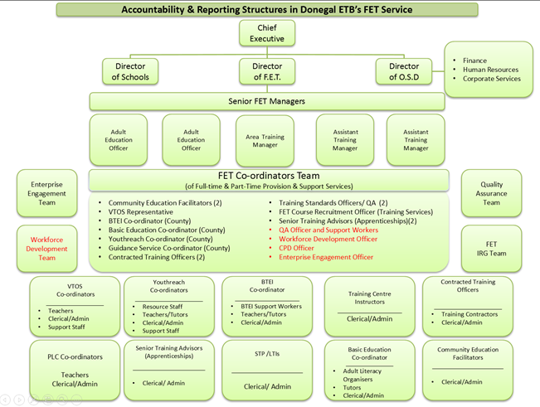

The structure allows for the executive decision making capacity of the FET Senior Management Team to report into the Chief Executive/Director's Forum. In turn The Chief Executive reports to the ETB board to update the board on developments within FET along with other matters.
Another layer of the current governance model are the monthly meetings of the FET Coordinators team which represent all the full time and part time programme types and the 13 ETB FET centres. The FET senior management staff along with the FET Director who chairs the group are present. The agenda for the group focuses on programme information and also cross cutting themes including QA, CPD, TEL, PLSS, Enterprise Engagement and Staffing and resources. The group provides a communication flow and a link between the centres, programmes and the FET senior management and allows the FET SMT to provide appropriate oversight. This is extremely important for the ETB and needs to be maintained in the revised governance structure. In the revised governance structure however groups such as this need to have appropriate terms of reference in order to formally and routinely provide the distillation and analysis of information from the FET centres and programmes to FET senior management. When such is in place information can then be used for information purposes only or for decision making by senior managers.
Currently the implementation/working groups which the FET Senior Management staff have oversight of include the following:

Table 3: Stakeholder and Working Groups
FET Coordinators Team-All programme types represented e.g., Youthreach, Apprenticeship, PLC, Community Education, Traineeship, VTOS, BTEI, Literacy,
Quality Assurance Working Group-All programme types represented e.g., Youthreach, Apprenticeship, PLC, Community Education, Traineeship, VTOS, BTEI, Literacy,
Results Approval Board/Panel-SMT and QA Coordinator/TSO
ETB/DSP Interim Protocol Group-SMT and Guidance and recruitment
Communications Advisory Group-Cross programme and ETB membership
Enterprise Engagement Working Group-SMT and programme staff

The Quality Assurance working group provide information and make recommendations to the FET SMT. They are primarily responsible for the development of resources and materials for programmes and in advising on assessment related matters and resource implications. Along with this they provide feedback on how the current QA systems are operating and discuss local QA policies and procedures as well as being informed on national sectoral projects by the Chair. The group is chaired by the AEO who sits on the national ETBI/QQI Forum. The chair of the working group has also been involved in a number of national ETBI led sectoral projects on quality assurance and disseminated this information out to FET Management, the QA staff, centres, schools and programmes. There is a comprehensive knowledge base and cross programme understanding currently in place within the ETB’s FET QA working group. This has been helped by the integrated nature of the ETB’s FET staff and the cross pollination of ideas between both training and further education. Qualifications approval of qualifications from other awarding bodies will become cross centre and programme as needs arise in provision planning. Knowledge can also be gained from other awarding bodies and the governance arrangement which they stipulate and these can be adapted to fit with the QA policy and guidelines developed by the Donegal ETB.
The Employer Engagement Working Group has been established to build and maintain relationships with employers in the region and was seen as an engine to drive feedback from employers on the ETB’s programmes and services. It was created to dovetail also with the work being undertaken by Regional Skills Forum. An important initiative that has been implemented arising from this relationship has been the launch of the ‘Employers portal’- (http://www.donegaletb.ie/employers/) on the ETB website where employers can feed into the ETB thus creating key stakeholder engagement.
The ETB in 2017 established a Communications Advisory Group whose purpose is to provide strategic direction on Donegal ETB’s communications structures and operations and to clearly communicate who Donegal ETB is and what Donegal ETB does.

4.2 Evaluation of Governance under QQI Core and Sector Specific Guidelines
Following on from the findings of the Governance questionnaire undertaken by the ETB and external consultant a number of enhancements based on the reports findings and recommendations will be put in place to improve governance of quality assurance within the Donegal ETB.
One of the key improvements of this new governance arrangement will be for the objective oversight of quality assurance within the ETB. It will help to create a separation of QA responsibilities from the planning, decision making and approval role of the FET SMT thus allowing for improved objective oversight. An appropriate terms of reference will be developed for the new Quality Assurance oversight group and its composition will be made up of suitably qualified personnel with who have knowledge and experience of the appropriate resources and standards that will need to be maintained to support the delivery of programmes.
The QA Oversight group will have a reporting role into the CE/Directors forum in order to progress items as necessary onto the ETB risk register as required by the QQI QA Core guidelines. The proposed governance model is outlined in the diagram below and shows the inputs as prescribed by SOLAS and the FET strategy with the quality assurance process and procedures being adhered to in the programme design, development, approval, delivery, evaluation and governance required by QQI.

Figure 5: Proposed new Governance Structure
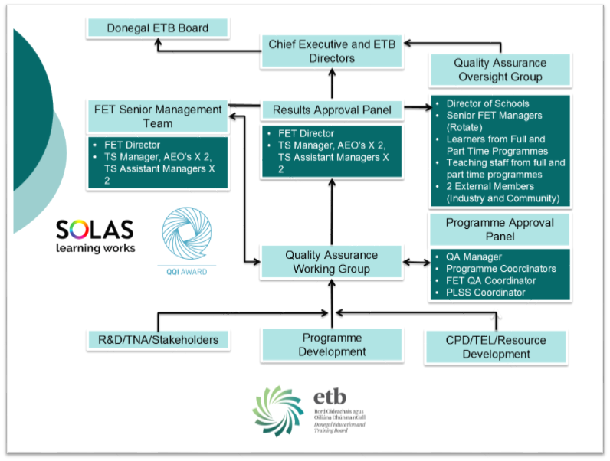

The need for a Programme/Course Approval Board is evident within the current governance model. The current QA working group does not have the authority to approve or recommend current programme proposals which may be part of a process of programme planning by FET management. Programme planning must also be aligned to the SOLAS overarching planning parameters which will allow for the funding the education and training programmes. The controls that would be required for programme approval are also dependent on the PLSS which at present has a function for senior FET managers to approve a course/programme to be scheduled on the calendar. This however at present is limited to serving as a commitment to approve the funding/budget allocation to the course. There is an inherent need for systematic programme planning to be built into this process and a vital component of this will be the formation of a Programme Approval Board. The QA working group can make recommendations to the Programme Approval Board for the development of materials/resources that are required to deliver such programmes. When such a Programme Approval Board is in place, it will be able to advise of the further resource implications for planning such a programme including CPD for staff/teachers.
Other stakeholder engagement groups such as the Enterprise Engagement group, Communications Advisory group and the DSP working group can also inform the Programme Approval group and integrate findings and R&D in progressing proposals to the QA Oversight group.

4.3 Governance Planned Actions

- Terms of Reference will be developed for the FET Coordinators group and QA Working group with procedures which allow both groups to condense and distil information that is appropriate for senior FET managers. The terms of reference will allow for the processing of information from both to be utilised by FET SMT for ‘information purposes’ such as feeding into the SOLAS/FARR reporting process and also for ‘decision making’ in programme planning and development along with the other areas as required by the QQI QA guidelines.
- QA Oversight Group will be established which will:
  - Assess the development of new QA procedures and QA handbook in line with QQI Core and statutory guidelines.
  - Have oversight of the procedures for the development, delivery, monitoring and review of planned programmes
  - Assess planned courses for appropriateness within the ETB strategy and current planning and funding parameters as defined by SOLAS.
  - Report and make recommendations on QA considerations and feedback from the evaluation of the Programme delivery, Assessment outcomes and Results Approval findings.
  - Produce executive reports that will help improve teaching and learning within the ETB.
- Programme Approval Committee established which will
  - Assess a proposal from a centre/programme - the capacity, facilities, staff resources, materials and QA requirements required to deliver a new QQI programme or qualification from a third party awarding body.
  - Advise on the QA considerations to deliver such a programme including staff development needs, learner feedback from previous instances of delivery and the requirement for programme and assessment materials/resources.
  - Decide how a course is to be scheduled on the PLSS calendar and provide details of the QA processes applied to the QA Governance Oversight group.

5: Delivery of FET

5.1 Programme Design, Delivery and Review
Donegal ETB delivers a range of programmes which were developed to lead to Major Awards at QQI L1-L6 under the Common Awards System (CAS); it also delivers a number of non QQI awards such as City & Guilds and industry-certified courses and programmes.

Donegal ETB engaged in the shared programme arrangement in developing former FETAC awards. Upon amalgamation with the two former FÁS centres, the ETB inherited their suite of shared national programmes. It was evident that there was duplication in the case of some of the awards at Levels 3 to 6. Nonetheless, programmes aims, target learner and programme design structure differ. The shared programmes used by the ETB in many cases were designed to be broad, encompassing a wide variety of adult learners with a social inclusion and educational focus. At levels 5 and 6 the shared vocational programmes were designed for specific learner groups (e.g., PLC learners), with a broad range of elective modules. Prior to the common awards the former VEC utilised NCVA programmes to claim major awards, with programmes based around specific learning outcomes (SLOs).

The former FÁS programmes were designed in two strands: programmes at levels 3 to 4 were developed for learners in supported community environments with support from training centres programme staff; programmes at levels 5 and 6 had an industry focus and were designed for long term unemployed adult learners with a focus on labour market participation. Both programme types adhered to programme design required by FETAC. Training services also had programme design processes in place where third party awarding bodies were used in the programme structure. Prior to common awards the process of interim standards within FÁS allowed learners to claim a major award using a mix of certifying bodies along with a FETAC component award. Under the new ETB structure, delivery of quality FET provisions is dependent on good programme design, quality teaching and learning and fair and consistent assessment.

5.1.1 Work-based learning
Donegal ETB are engaged in developing three work-based learning programmes as part of the national career traineeship model. The programmes have an increased focus on employer engagement, including the development of occupational skills profiling. Once this occupational skills profiling is complete, a customised programme will be chosen from the national programme database.

5.1.2 Themed and integrated programmes
An integrated tourism programme at Level 3 - Cultural Heritage and Awareness of Tourism (CHAT) – was developed to support the development of generic skills through the theme of culture and heritage.

Donegal ETB is currently engaged in integrating generic skills with horticulture. This will support the engagement of members of rural communities who have an interest in gardening and agriculture.

5.2 Programme Design, Development, Delivery and Review
Current programme development is determined by but not limited to the following:
- FET Strategy 2014-2019
- ETB Strategy Statement 2017-2021
- National Skills’ Strategy
- Action Plan for Education 2016-2019
- SOLAS overarching parameters and FARR funding model
- TEL Strategy
- a range of other national strategies research and local initiatives
- Learner Feedback
- Employer Feedback

Programme selection is influenced by the National repository of programmes available through the PLSS. This system facilitates an ETB response to course needs identified by local stakeholders (employer group, community group, feedback from DSP) through the ability of creating local programmes on the Donegal ETB partition of the PLSS. Recognition of programme validation requirements must be taken into consideration however when utilising this facility within the PLSS.

To satisfy the new QQI programme validation requirements, Donegal ETB must:
- Build capacity among its QA staff and coordinators in programme and course and curriculum design
- Align programme development with the strategy of the organisation.
- Implement a more collaborative approach to programme development to meet the needs of the various stakeholders.
- Implement a training and educational needs analysis as part of a clear rationale for programme development
- Take cognisance of consequent resource requirements.

With Donegal ETB’s Strategy Statement now in place and approved by its Board in November, the ETB will be aligning new programme development with this strategy along with other planning considerations. A revised programme development procedure will be developed and takes cognisance of a number of factors. Oversight of this will be in the terms of reference of the Programme approval committee so that any future developments are done so within strategic policies and procedures.

A procedure will also be developed for new programme development to ensure that it meets the requirements of the following:
- Internal and External Consultation takes place
- NFQ and ATP policies are taken into consideration
- Work based learning is considered in the development
- Learner induction, communication, supports, feedback and learning environment are addressed in the development.
- Planning is considered in programme development around the new QQI validation policy and criteria

Figure 6: Programme Development Cycle
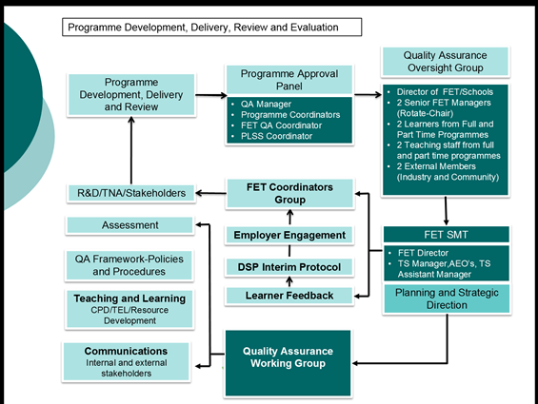

5.3 Teaching and Learning
Donegal ETB has always had a strong ethos of promoting teaching and learning and has actively encouraged staff to develop their approaches to such. Teaching and Learning has been supported by the development of materials and resources and implementing a range training and development for staff.

5.3.1 Materials and Resources
Resources were developed to support the delivery of programmes to students from levels 1 to 4. General resources were developed to build literacy, numeracy and ICT skills. The resources were level specific and linked to the content and outcomes of each programme. These resources have a local context and each student is given their own copy. Tutor guides, prepared by coordinators and organisers, support delivery. Dedicated resources have been developed to meet the needs of specific target groups – Computer Operator Wizard (COW) is a resource developed for participants from the farming community. At levels 5 and 6, materials were sourced and made available to both teachers and students.

5.3.2 Continuous Professional Development
Tutors, teachers and facilitators were supported to participate in training and development in-service courses. Term meeting for part-time tutors were organized as a mechanism for sharing resources and expertise. In-service training has included:
- creating a positive classroom environment;
- utilising technology enhanced learning;
- supporting learners with dyslexia in the classroom;
- differentiation
- project maths
- integrating literacy

In order for the ETB to build its capacity and ethos of a teaching and learning organisation and to satisfy the QQI core QA guidelines, continual professional development both in service and themed will be integral to this. SOLAS have committed to a national CPD strategy for the ETB’s and one of the core themes to this strategy is Quality Assurance. Until this strategy and resources are put into place a number of key initiatives by the ETB are to be actioned to address specific shortages in this area and as will be required by the FET service

5.4 Teaching and Learning Planned Action
- A key Themed CPD calendar will be issued on a yearly basis which helps to build the capacity of ETB staff in Teaching and Learning and Quality Assurance. The CPD calendar will be non programme specific to build on integration and complement the SOLAS and Further Education and Support Service quality assurance themes being developed
- A procedure will be designed to satisfy the requirements of the Core and Sector Specific guidelines around CPD for staff in order meet new programme requirements.

5.5 Technology Enhanced Learning

Donegal ETB has engaged in the promotion of technology enhanced learning and its integration into the programmes and delivery of FET provision. This is also referenced in the ETB’s strategy as one of the goals ‘Teaching and Learning’. As part of this engagement, a number of teaching and learning resources are being utilised and implemented both in the classroom and through distance learning opportunities outside of the traditional learning environment. As part of the national TEL strategy being rolled out by SOLAS, Donegal ETB is currently completing a TEL baseline activity and action plan which will form a continual improvement plan in 2018. In order to implement the action and improvement plan specific and measurable tasks based on four key themes will be documented. Confidence in using technology to enhance learning is a key element of success and in order to achieve such, ongoing professional development opportunities across programme types and levels needs to be instigated and embedded into the teaching and learning ethos of the ETB’s FET staff and collaborative providers and partners. Within a number of the ETB’s programmes Technology enhanced learning is utilised to enhance the learning experience and also to complement the teaching and learning outside of the non formal learning environment. The new version 4 of the SOLAS validated craft apprenticeship programmes (SOLAS Coordinating provider) integrates two modules in communications and team leadership into the phase 2 of the delivery in the training centres. To do this Moodle is utilised for learning, practice tests/mock tests and also for marking and grading of some of the assignments with feedback given to learners on the summative assessment process through their online learning accounts.

The utilisation of SOLAS E-College and the online learning resources associated with this are utilised across FET programmes within the Donegal ETB. Because of such a ‘Multimedia’ programme was locally developed which allows learners to undertake entry level learning in Information Technology in a facilitated learning environment.

The national license with Prodigy learning as procured by SOLAS also allows for utilisation of teaching and learning resources on such programmes as ‘Multimedia’ where a blended learning approach is utilised. This includes using Gmetrix as a pre and post learning assessment tool and skills checker. Within the next year Donegal ETB will utilise such resources as Prodigy learning to build our capacity in digitization and IT skills among teaching staff and integrate the resources associated with such in building capacity in teaching and learning across programmes.

In implementing the baseline activity plan for the TEL Strategy as required by SOLAS Donegal ETB will also satisfy a number of teaching and learning requirements including CPD for staff, programme development and pedagogy. An evaluation of the TEL baseline activity plan will take place during 2018 with key milestones and measurable achievements in order to progress the plan.

5.6 Teaching and Learning Planned Action-TEL
- Donegal ETB will implement the TEL strategy and the four key themes within it. These include Infrastructure, Pedagogy and CPD, Content Creation, Access and Sharing and Organisation Structure, Policies and Practice. The ETB will develop policies and procedures around TEL and its utilisation in formal and non-formal learning environments.

5.7 Consistency of Assessment
Presently Donegal ETB operates two quality assurance systems allowing for certification claims for FET learners. One for the Further Education provision which was formally agreed with QQI and the TQAS system for training services programmes including the national coordinated apprenticeship Phase 2 delivery in the training centres.

To satisfy the core and sector specific QA guidelines as outlined by QQI the ETB has begun to synergise and streamline policies and procedures from both systems. In 2018 a hybrid of both systems will form the new policies and procedures of the Donegal ETB’s QA system.

One of the key strengths of the ETB’s current assessment procedures is the impartiality and separation of staff in the appointment of External Authenticators. In implementing this approach to appointing EA’s, the capacity and experience of the training centre Quality Assurance staff (Training Standards Office) are used in appointing EA’s for the Further Education and Training centre programmes, centres and PLC colleges. The recent appointment of a FET QA coordinator to replace the TSO has allowed for such capacity and also helps with the integration of FET staff across the various programmes.

In the May, August and December 2017 assessments, a centralised approach in appointing External Authenticators was utilised for the authentication of awards at levels 5 & 6 in Childcare, Healthcare and Youthwork and the same EA’s were used to try to achieve an acceptable standard and consistency across centres and programmes. The feedback and learning gained from the process helped to inform recommendations for improvement in following certification rounds while also highlighting issues that required attention in programmes and centres. Areas of good practice were also highlighted by the EA’s and this helped centres implement improvement plans based on EA recommendations. To implement this, EA feedback is collated along with internal verification findings and summaries in a report which is then presented to the Results Approval Panel. Continual improvement actions are then disseminated back to the coordinators and centres for actioning prior to the next EA visit in following assessment rounds. This helps to create centre and programme improvement plans. It is hoped also to analyse the findings and themes that are apparent from the EA reports at the various NFQ levels and create and overall summary report after each EA round which will be presented to the QA Oversight group for analysis and comment if certain issues arise that require resourcing or further staff CPD among staff. Feedback must be issued to centres who will then create a centre improvement plan which will increase the benefits of the quality cycle.

5.8 Assessment Planned Actions

- To satisfy QQI Core QA guidelines, a policy and procedure will be developed by Donegal ETB to create centre and programme continual improvement plans which will be based on feedback and themes from the authentication/external verification process.
- A procedure to be devised around analysing themes that arise from the Assessment process and these will be presented to the QA Governance Oversight group for recommendations.

5.9 Assessment Integrity Security and Information
In order to maintain assessment integrity and in particular the issuing of examination papers Donegal ETB resources an examinations office which is also separated from the centres/programme coordinators and teaching staff in order to maintain impartiality. The exams office is located centrally and procedures are in place for the requesting, dissemination and maintenance of the exams for each of the validated programmes and modules which have examinations associated with their assessment plan. This is administered for the Further Education programmes. The training standards office in the training centre maintains an assessment register of the dissemination of all assessment packs to both in centre and second providers. Assessment packs are printed from a secure online system as maintained by SOLAS. For apprenticeship assessment instruments the CACMS system administered by SOLAS is also utilised by the training standards office. This office maintains assessment security and dissemination of assessment packs in a controlled and secure way.

Assessment plans are submitted by each assessor to programme coordinator/centre/training standards office. These assessment plans are also distributed to learners at the start of each module/academic term so learners are made aware of the assessment schedule on their course. To help standardise the assessment plans, a key certification date’s document is circulated to all teaching staff at the start of each calendar year. This helps assessors and coordinators plan for assessment/internal verification/external authentication and results approval.

Assessment briefs are maintained in the Assessor Modular Folders (AMFs) for each of the validated modules for the further education provision whereas briefs and assignments for training service programmes are maintained on CAMS. These are issued to each assessor/second provider with a signed declaration that they will maintain the assessment security of the briefs and assessment instruments while in their possession. These assessment instruments are centrally devised.
In both systems, updates to the assessment briefs have not been undertaken for some time and in some instances not since 2012/2013. ETBI are currently resourcing staff from the training centres to update some of the training centre assessment instruments and briefs.

Donegal ETB however requires some staff development in the designing of new assessment briefs. As an initiative to try to build capacity among teaching staff in this area, CPD is planned in 2018 where some teaching staff will undertake a QQI L7 special purpose award in Assessment Practice.

Key stakeholders will have to be involved in the designing of briefs and examinations, including feedback from learners and industry involvement also. Peer review of the assessment instruments will also need to take place along with pilot testing. It is hoped that with the new sectoral approach to authentication, external authenticators could be used as a quality assurance resource and help to advise assessment writers at stages of development of assessment resources thus ensuring the validity and reliability of assessment.

5.10 Assessment Appeals
Learners currently have the right to appeal assessment results and to ask for their assessment to be remarked if they are unhappy with an assessment result or a number of other factors in the assessment process including assessment conditions or extenuating circumstances such as compassionate considerations. ETBI in conjunction with the ETBs are working on a new set of assessment regulations for the FET sector and ETB’s which will outline the process and procedures to be implemented in the assessment appeals process. SOLAS who are the coordinating provider of the apprenticeship programmes at phase 2 within the training centres have an appeals process for apprentices under the TQAS system. It outlines the various grounds for activating an appeal and is available to apprentices.

5.11 Drafting
As part of the process of summative assessment and feedback to learners Donegal ETB’s QA policy encourages learners to submit drafts for feedback prior to submitting for assessment. The process of feedback however varies across centres and programmes and learners may sometimes use the opportunity as a means to achieve feedback to gain a higher mark or grade from their tutor. This compromises the academic integrity of the tutor and the feedback given in these instances does not lead to a critical evaluation by the learner of their work.

In order to implement a better approach to drafting particularly on level 5 & 6 programmes a pilot initiative for outline drafting will take place on one of the Level 5 Health Service Skills programmes within BTEI provision with a scaffold and support to help learners critically analyse their assignment work.

5.12 Reasonable Accommodation in Assessment
Reasonable accommodation is assessment is currently inconsistent across the programmes of the ETB. Assessment accommodation by other awarding bodies can be claimed using medical evidence of a specific physical disability and the appropriate supports provided in order to ensure that the assessment is conducted in a fair way so as not to advantage the learner. The state examinations commission operate accommodations for Junior and Leaving Certificate. Under the TQAS a system is in place for assessment accommodation through the ‘Request for Assessment support’ procedure however there is in many cases a lack of clarity around the appropriateness of the medical evidence particularly when it comes to a learning disability or areas such as dyslexia.

In some cases learners and apprentices are presenting with a GP cert diagnosing dyslexia or in other cases a primary schools educational psychologists report outlining learning difficulties. In instances like these the judgment rests with QA staff as to whether to provide or decline an intervention of assessment support.

As part of the national collaborative working group on the assessment reasonable accommodation is considered and policies and procedures are being devised.

A local initiative which was undertaken with the support of the literacy service and the schools psychologist was to pilot an approach for all new registrations that were taking place in the training centre in Letterkenny. It utilises the Skills checker as developed by the literacy service which tests literacy levels and if the learner is found to be low level on the checker then they are offered to undertake a WRAT4 assessment which can diagnose learning issues. Training services can then accept this as evidence for Assessment accommodation and the learner can then also avail of further literacy supports outside of formal learning or classroom time.

5: 13 Results Approval
The Results Approval Panel meeting provides an opportunity for the FET senior management to review results submitted by centres and programmes and address assessment issues and decisions that impact on the fair and consistent assessment of learners. The meeting also provides an opportunity for recommendations and actions to be implemented by centres and programmes as part of a continual improvement process. The ETB will move towards a centralised approach to results approval with both FE and T being included in the meetings. A terms of reference for the board will be developed.

Consideration is given during the meeting on findings of Internal Verification, External Authentication and Peer Review. The decision making and approval function of the panel allows for academic oversight of results, centres and programmes and helps to maintain consistency of assessment and the national standards on the programmes.

Documentation, reports and minute templates and records are stored securely in the QQI team drive which the FET QA coordinator has access to along with the Results Approval Panel secretary.

The terms of reference for the FE and the Training Centre Results Approval vary however. To create consistency and to satisfy the QQI QA guidelines a common terms of reference will be devised outlining the quorum of the group and the academic decision making capacity of the group

5.14 Assessment Integrity Planned actions

- To improve the standard of assessment instruments, the ETB will implement CPD for staff in designing assessment instruments with a view to updating the centrally located assessment briefs and examinations available for both FE & T. Stakeholder feedback will be sought including learner feedback on the assessment process and other industry and higher education stakeholders.
- To inform learners better of the assessment process and plans, a key dates calendar for learners will be created in tandem with the one used by assessors/coordinators. This will be disseminated by each assessor, outlining the assessment plan for learners on each programme and giving details of types of assessment and how to appeal assessment results.
- To satisfy the QQI Core guidelines section 6 on fair and consistent assessment of learners, Donegal ETB will begin to implement the national policy and procedures as outlined in the Assessment handbook currently being undertaken as a FET sectoral project through ETBI.
- Procedures to be developed around implementing centre and programme improvement plans after each Results Approval Panel meeting. Outcomes of the EA report recommendations and internal verification findings will be fed back to the centre/programme for implementation, action and improvement in teaching and learning and programme delivery.
- Terms of reference to be developed for the Results Approval Panel.
- Summary reports of the findings of the Results Approval Panel Meetings will be evaluated at the QA governance Oversight group with actions and improvements identified.

5.15 Public Information and Communication
As part of the Integration focus of the ETB in its amalgamation with Training Services, Donegal ETB developed a website to host information on its various services and also to communicate its FET programmes, learner information and supports available to learners engaging in FET. One of the innovative features of the site was the integration of the course finder from the PLSS course calendar.
As part of the requirements of section 9 of the QQI Core guidelines the ETB will be in a position to publish evaluation findings and its quality assurance policy and procedures on this website when they are produced and approved. Currently policy, procedures and other resources are published on the internal staff intranet.

5.16 Public Information Planned Actions
- The ETB will put procedures in place to publicly publish required QA reports on their website in an accessible and easy to reach manner. These will include policies and procedures on QA as and when they are developed.
- Learner information in relation to courses and programmes will be made accessible on the website and also in other published documents, including the prospectus.
- Communication of the QA documents will be an agenda item at the Communications Advisory group meetings in order to channel the information to all stakeholders.

5.17 Staff Recruitment
Teaching and tutoring staff are recruited from FET panels; however with the moratorium on recruitment it has become increasingly difficult to get the appropriate staff on a long term basis. This has an impact on the variety and types of programmes being delivered. DES has approved only two quality assurance posts on their recognised lists for recruitment, both of which are in Training Services. Quality Assurance is increasingly being implemented through programme staff and coordinators and in most cases this leads to deficits in both work areas.

6: Learner Recognition and the Learner Experience

Donegal ETB provides programmes of learning from levels 1-6 on the NFQ. These are delivered on a part- and full-time basis under our current QA arrangements. Each validated programme has specific guidelines around learner recognition and admission regarding access to the programme, transfer and progression. Eligibility criteria linked to different government funding streams (e.g. Youthreach, BTEI, VTOS, Traineeship etc.) leads to restrictions such as age, unemployment status, educational attainment and disability among others.
Programmes within the training services funding streams (Specific Skills Training, Traineeship, Specialist Training Providers) had a strong association with the Department of Social Protection and relied heavily on the support of Intreo Officers for referrals. The Further Education programmes (Youthreach, PLC, BTEI, VTOS, Literacy) recruited learners through the work of organisers / coordinators, who actively promoted provision and developed a range of networks with both statutory, community and voluntary agencies.
Since the launch of the PLSS learner database and its integration with the national website www.fetchcourses.ie in August 2017, learners can now make their own application to a course, programme or funding stream and can also apply for multiples of part time courses and one full time course at any one time. Learners create their own online account and populate online forms outlining their age, educational attainment, welfare status and other social inclusion data. The system however has created complexities in having to validate learner information at screening and admissions stage onto a programme or course.
Donegal ETB’s Adult Guidance and Information service and the recruitment service within training services have a proactive and integrated approach towards learner screening, admissions and enrolments and make such decisions based on fit for purpose practice and principles. Programme entry requirements however need to be streamlined and standardised across all our programmes on the NFQ. There is a need to apply a similar and consistent set of standards to all learner regardless of whether they self refers to a course, applies through a DSP case officer, comes in through an organiser or through our Adult Guidance information and recruitment service.
Donegal ETB accredited learners using Recognition of Prior Learning in 2016 and 2017. The project specifically focuses on targeted groups of those in the workforce or transient employees within a specific sector. Two specific case studies are included in the appendices of this report.
The QQI core guidelines require regulations and procedures which are “consistently applied, covering all areas related to learner admission, progression, recognition and certification of awards”. Donegal ETB recognises learners as key stakeholder and acknowledges the need for common policies on admissions and access across all the various funding streams. This is also required under the QA guidelines as well as the validation requirements for new programmes.

6.1 Learner Admissions
Donegal ETB programmes strands (VTOS, YouthReach, Literacy, STPs, Training Services) assess learners at point of entry to ensure that they are entering at a level to suit their abilities and that will enable them to succeed. A tool, Skills Checker, is used by some programmes and Donegal ETB’s Adult Learner Guidance Service is used by others in recruitment. With the exception of community education and some family learning courses, learners can avail of the option of accreditation.

6.1.1 Learner induction to both the provider and the programme.
Handbooks are provided for each learner. While these are tailored specifically to each programme, they also provide the same background information on Donegal ETB.
English Language provision
Handbooks are provided in the learners’ first language. Donegal ETB provides handbooks of information for learners in 10 different languages.
Levels 1 to 3
Handbooks are provided in booklet format, with clear information and contact details.
Levels 4 to 6
Handbooks are detailed and presented in folders. Information on assessment, exams and marking schemes are included.
Induction is carried out by programme staff at the first meeting of the group. This takes the form of a tour of the centre, information on personnel, and clear information on term dates.

6.1.2 Processes and tools to collect information
Management Information Systems are used to collect information on learner progression and completion rates. The PLSS system allows for management information reports in order to collect this.

6.1.3 Fair recognition of education and training qualifications, periods of study and prior learning.
Prior learning is recognised at point of access to ensure that learners enter at the correct level on the NFQ. Formal qualification, as well as both non-formal and informal learning is considered as part of the access process. Prior learning is also used for exemptions for some modules, particularly in apprenticeship programme. In 2016, Donegal ETB used prior learning for certification at level 3 on the NFQ and in 2017 at level 5.

6.2 Learner Admission Planned actions

- Donegal ETB will develop learner admission procedures based around the principles of Access, Transfer and Progression within the QQI Core and sector specific guidelines.
- An action is required to create a common learner handbook/portal for ETB learners with further additional induction information dependent on programme type.
- Utilisation of the PLSS learner data on information on progression and completion rates within programmes and utilise this data in the QA governance oversight group.
- The ETB will further progress the RPL project which it has been engaged in nationally and will create further develop its policy and procedure for such within its QA system

6.3 Learner Experience and Learner Supports
The learner experience or journey while on a programme is further enhanced by a range of supports which are outlined below:
Outreach Provision
Donegal ETB delivers courses in 17 dedicated ETB Centres and in more than 60 community and outreach venues, including the Aranmore and Tory Island.
Recruitment and Promotion of provision
A variety of media, coupled with a range of methods are used to promote and give information on courses. These include: information sessions, learner fair, Donegal ETB Website, networking with both statutory and voluntary agencies, brochures, leaflets, social media, publicising learner presentations and case studies. Administration, recruitment and reception staff participated in frontline guidance and literacy awareness training.
Modes of delivery
Delivery methods place the focus on the learner and include the following: small groups, discussion, experiential learning (cultural visits, organising and participating in events, guest speakers and use of technology).
Guidance, Advocacy and Counselling
Learners are able to avail of additional supports as follows: Levels 1 to 3 are supported by Adult Literacy Organisers who have participated in frontline guidance training; levels 3 to 6 are supported by Donegal Adult learner Guidance service; Youthreach learners are supported with Counselling and Advocacy Service; Training Centre learners are offered literacy, study skills and specialist support services.
Learners on the VTOS and BTEI programmes also avail of the Guidance service during the initial induction weeks of the programme and continually throughout the 1-2 years of their programmes. This includes career guidance, supporting learners through one to one sessions and preparation for the workplace.
Support towards participation
Childcare support is provided through the CETs scheme and in ETB owned crèches.
Teaching and Learning - Supports for learners
Resources: Donegal ETB has developed a range of resources to support teaching and learning including:
Diversity and Universal Design: Accommodation is provided for learners where a need has been identified. In the past this has included: large print for a visually impaired learner and sign-language interpreter provided.
Assessment
Reasonable accommodation in assessment is also provided.
Staff Development
CPD and Professional Development seminars for staff to address learner needs e.g., Creative Methodologies, Mental Health issues, Equality awareness and proposed Universal Design.
Donegal ETB has a strong tradition of developing scaffolds and supports for learners on its programmes. Nevertheless, an integrated approach to gathering and analysing feedback on supports and resources provided would keep them current and ensure that they meet the needs of learners.

6.4 Learner Experience Planned actions
- A procedure and process of collecting and collating feedback from learners needs to be standardised across programme types and to be fed back into programme review.
- The requirement to update and standardise the learner handbook(s), including adding a learner charter, information on expected behaviour, and updating the learner supports and services that are available both in the learning environment and through outside services and collaborations.
- A requirement to review the learner supports and scaffolds available in the various programmes and implement procedures around their review and develop an integrated approach to the continual improvement of learner resources.
- Develop a learner charter and establish a learner forum with the goal of reviewing and refining procedures to improve the learner experience within our programmes and services.

7: Information and Data Management
The Donegal ETB have a variety of validated programmes from levels 1-6 that are visible on the QQI website and QBS validation services. As outlined previously these are shared programmes and also the former FAS programmes. In order to capture other data other than certification data the FET sector have designed the PLSS (Programme Learner and Support System) is a Currently FET provision is scheduled in the PLSS (Programme Learner and Support System) an ETBI and SOLAS collaborative project which acts as a programme repository for all of these national programmes as validated. The programmes scheduled programmes and courses feed the information about such programmes to local and national websites such as ‘fetchcourses’ and the Donegal ETB website course finder. Donegal ETB were involved in the pilot roll out of the PLSS programme database and repository.
Since the implementation of the learner database within the PLSS in February 2017 learner data is now available for analysis in the PLSS system. As yet however certification data from QBS is not available in the PLSS. To analyse this data the ETB still rely on statistical reports provided by QQI and the QBS system at a requesting centre level.
The QQI infographics site provides a graphical representation for the awards offered by the ETB. It also gives an age analysis and gender balance of awards conferred in the years since the data collection was published by QQI. Within training services of the ETB a number of data capture systems are used prior to results going up onto the QBS. Results are then uploaded by the IT unit in SOLAS to the QBS. Within the Results Capture system a MIS reporting capability is available giving breakdowns of results entered and approved by programme or course. It also captures data from other awarding bodies that have been entered. Another benefit of the system is the ability to print out broadsheets of the learners group results so that these can be used for sampling when completing internal verification and also external authentication. Trends in certification data can be collated in the system and management information is readily available. The apprenticeships coordinated by SOLAS have a similar system and within the phase 2 of the version 4 common award apprenticeship programmes moodle is also used to capture results and retain a record for the apprentice over the years of their programme.
In order to satisfy section 8 of the QQI Core guidelines the PLSS will be utilised to generate demographic information on the learner population within the ETB. It includes the facility to capture learner progression and attrition or drop out as well as completion and grade analysis once the RCCRS is integrated within the PLSS. Career paths and learner satisfaction rates will also have to be considered and may be integrated into the system in the future however in the interim local arrangements can be proceduralised to capture this.

7.1 Information and Data planned actions
- In the adhering to the Core and Sector specific guidelines a procedure will be devised to collate and utilise data from the various information systems to analyse and use the statistics for quality enhancement purposes and statistical reporting.
- The ETB will also devise a data protection policy for the secure storage of learner data and how it will be utilised and conform to the GDPR regulations.

8. Collaborations and Stakeholder Relationships
The ethos and culture of the Donegal ETB has always been one of working in collaborations and ‘Working in Partnership’ is identified as one of the three key theme in Donegal ETB Strategy Statement ( 2017-2021). Within the Section 5.1 of the sector specific guidelines QQI recognise that ETB as well as forming partnership and collaborations within in their own ETB will also collaborate together on sectoral projects coordinated through ETBI to meet the requirements of a comprehensive Quality Assurance framework for the sector.
A number of local collaborations and stakeholder relationships have been built and will help to inform feedback into the quality assurance system.
These include:
Community Collaboration: Extensive collaboration with community groups, Family Resource Centres, Pobal centres and Partnership Companies in provision of non-accredited and accredited courses at all levels within the literacy service; community-based BTEI programme and a grants-based community education service to ensure “bottom-up” approach in encouraging participation among learners who do not normally engage in educational activities. The Community Education Forum established in 2015 and supported by DETB which has representation from key community and statutory interests and was formed to ensure a strategic approach to delivery in the county and to minimize duplication. Qualitative research currently project currently nearing completion on the nature of community education in Co. Donegal.
DSP Collaboration: DETB/Department of Social Protection Working Group: This has been a development of the DSP interim protocol group and a memorandum of understanding is in place between the two organisations including data sharing between PLSS and BOMI. The group meets 3-4 times annually to explore issues such as analysing referrals between the systems to ETB programmes, information and clarification on entry paths for DSP activation clients who can avail of the programmes DETB deliver, inputs regarding materials, resources and support for DSP clients while on ETB programmes; development of new, relevant courses to meet the needs of the unemployed and county wide information and training events provided by DETB for DSP staff ( individual, small and large group) to ensure their familiarity with DETB provision and services
Enterprise Engagement Working Group: This is a cross service group was established “to foster stronger links with local enterprise and other relevant stakeholders and to formulate, coordinate and implement a coherent response by the FET service to the county’s training needs”.( TOR Appendix). One of the outputs from this group was the development and creation of the Employer Portal on DETB website so that employers can engage directly with DETB. A launch the Website portal took place in November and the project was a key initiative based on feedback in collaboration with the Regional Skills Forum and the need for employers to engage with FET as well as Higher Education within the region.
The ETB are engaged in a collaborative project with the Regional Skills Forum coordinating along with FIT and Letterkenny Institute of Technology to identify skills and training needs of ICT and Manufacturing sectors in the county, and allow for development of appropriate programmes to meet needs of industry. This initiative will be key in forming the development of new programmes as required in the stakeholder engagement in their development while also meeting the courses to employment the damans of these sectors.
With the memorandum of understanding in place between Letterkenny Institute of Technology and the EBT one of the key strategic focuses of this MOU is to build progression pathways to HE from the FET programmes and build closer linkages between both organisations. The ETB is currently working on analysis of various pathways to HE for entry from Level 5 & 6 programmes and to see how we can help to create more maps and paths into the LYIT from the ETB.
Strong links have also been formed between the other statutory agencies in the county and the ETB has been able to meet the demands for employment and enterprise growth by closely aligning our programmes and services with these agencies through various fora and collaborative projects. These include Údarás Na Gaeltachta, The Local Enterprise Office, The Chamber of Commerce, and the County Council. It is important that these links are maintained and are utilised in order to better inform programme and course development to meet the unique demands of the county.
National collaborations and QA sectoral projects coordinated by ETBI will help ETB’s satisfy the comprehensive nature of the new Core and Sector Specific Guidelines include a number of projects that will help form a framework for QA procedures initially in relation to Section 7 of the Core guidelines:. These include the production of an assessment handbook, consultation and new guidelines around external authentication, newly developed materials and resources for the Work Experience Module at levels 3-6 as utilised in the shared programmes, a FET Validation working group formed in collaboration with QQI in progressing section 3 of the guidelines and also an analysis and case studies of governance and management structures within the ETB’s as required by section 1 of the core guidelines.
Networks and collaborations also exist though the ETBI Quality Assurance forum with the Further Education and Support Service who are involved in providing support and continual professional development opportunities for FET staff. This relationship has developed further into the involvement of FESS in the national CPD strategy for QA being rolled out by SOLAS.
Further memorandums of understanding and service level agreements are in place with SOLAS also in the delivery of the Phase 2 apprenticeships in the centres and future collaborations may arise with the new apprenticeships in development.
Contractual relationships also exist with other awarding bodies and testing/assessment systems that are outside of the Irish jurisdiction. These include City & Guilds, ITEC, Microsoft, Pearson Vue, ERS, OFTEC. It is important under the new QQI guidelines that these agreements are proceduralised and subject to internal and external QA procedures.
Relationships also exist with External Authenticators and external panellists and it is important to document these relationships within the QA procedures and handbook. These external experts are sometimes procured as a professional service and in other instances paid as employees of the ETB when completing authentication work for the FE centres. It is important to maintain objective separation and for their not to be a conflict of interest in their work for the ETB.
The ETB through Training Services also engage in the procurement of further education and training programme delivery through contracted training. The policies and procedures developed by the ETB will have to include the devolvement of these procedures within the contracted training framework that the ETB has entered into. This devolvement of these procedures will include not just commercial or contracted training providers but also community groups and specialist training providers who deliver validated programmes on behalf of the ETB.

8.1 Evaluation of Collaboration and Planned Actions
- As required by the Core QQI statutory guidelines the Quality Assurance procedures developed “include provisions for due diligence on the reputation, legal status, standing and financial sustainability of any such parties or second providers involved in provider provision, or related services”.
- The nature of arrangement of these partnerships and second providers is available in published format.
- Procedures in place for engagement as a professional service or other with Expert Panellists, Examiners and Authenticators.

9. Apprenticeships/Traineeships & Work Based Learning

9.1 Apprenticeships
Currently Donegal ETB delivers Phase 2 of four of the national craft apprenticeships Apprenticeship in the training centres in Letterkenny and Gweedore. These are Plumbing, Electrical, Motor Mechanics and Electronic Security. Plans are in place for an intake Phase 2 of the Carpentry and Joinery apprenticeship in the centre in Letterkenny in Spring 2018. Scheduling of these Phase 2 intakes is maintained nationally by SOLAS apprenticeship services and as apprentice registrations grow the centres and their facilities and instructing staff are able to facilitate.
The Quality Assurance for the Phase 2 of the Apprenticeship programmes along is coordinated through SOLAS and utilises the Training Standards system with set procedures in place for maintaining the assessment and academic integrity of them. Curriculum and assessment are devised centrally by SOLAS and disseminated out the centres. The assessment system is administered by the Training Standards office staff.
In the initial call for new apprenticeships in 2015 the Donegal ETB submitted a proposal for a Welding apprenticeship. This progressed and was approved as a category one new apprenticeship proposal as endorsed by the apprenticeship council and SOLAS. A national consortium of employers in the engineering sector came together with letters of approval for the proposal to be progressed. A steering group was formed chaired by the Donegal ETB and inclusive of employers and other ETB staff members from Cork and Kerry ETB’s and IOT’s. The proposal however was not progressed any further in 2016 when the steering group all agreed that the industry providers were not in a position to fund the apprentices both on and off the job while undertaking their training.

9.2 Traineeships
Donegal ETB has been engaged in the traineeship model of programme delivery for some years now through the former FÁS validated Traineeship programmes. These are delivered primarily through our Training Services provision. A significant aspect of these programmes included Work based learning and learner record assessment and workplace competence schedules were signed off and assessed in the workplace by a workplace assessor/mentor.
These traineeships included:
- Outdoor Activity Instructor Traineeship
- Beauty Specialist Traineeship
- IT Support Specialist Traineeship
- Early Childhood Care and Education Traineeship
- Healthcare Support Traineeship
Under the new National Career Traineeship model in 2016 Donegal ETB in conjunction with Galway and Roscommon ETB got approval to develop a new ‘Career Traineeship in Digital Sales and Marketing’. A demand was seen by employers for the need to have an online presence particularly in promotion and advertising of their products and services using social media. In conjunction with the innovation unit within SOLAS the new traineeship was developed utilising the City & Guilds 7513-30 Diploma in Digital Marketing qualification. This programme is currently running and SOLAS are conducting and evaluation of it at present. A challenge in developing the programme was integrating and assessing the workplace learning competencies. The initial proposal approved by SOLAS included utilising a QQI component award in Work Experience to allow for assessment in the workplace. This however posed problems within the SOLAS programme funding mechanism when moving from the PLSS course calendar to the FARR reporting system. Two new Career Traineeships are in development by the ETB at present: Hospitality (NFQ Level 5) and Engineering (NFQ Level 4). These are being developed in collaboration with relevant industry partners. To do this occupational profiling is ongoing with employers consulted on their requirements while learners would be engaging in work placement with them.
Extensive on-going engagement with Hospitality Industry in the North West has been ongoing over the past two years, including the Irish Hotel Federation, local hotels and Tourism Ireland. Collaborative projects undertaken including development of new courses to meet the needs of the industry (on-going) and the adaptation of existing courses is based on feedback from employers e.g. inclusion of social media and customer service modules within Hotel and Front Office Skills Programme. The ETB has utilised employers from industry to speak at staff conferences and seminars and hoteliers have hosting of course participants by hotels -“A Day in the Life of a Hotel”- so that learners can hear what is required by employers.

9.3 Skills for Work
The Skills for Work programme which is nationally coordinated by DDETB is a national programme which is DES funded and allows for the upskilling of employees with no previous or expired accreditation as required in their workplaces. The Skills for Work - coordinator who is shared with MSLETB runs 25-30 courses per year under the programme with courses taking place both in the workplace and in the FET centres.

9.4 Learner Work Experience and Work Practice Assessment
Learners on the Further education programmes engaged in the work experience modules at levels 3-6 since September 2017 are utilising the sectorally devised update to the module. This includes revised marking schemes and indicative content with the stipulation that all elements assessed in the workplace must be completed in order to claim the component.

9.5 Planned Actions Work Based Learning
- Procedures to be developed for engaging with employers to be developed so that feedback can be gained regarding both work placement and programme improvement.
- Procedures to be devised around training for Work based assessors so that they are aware of their role within the QA processes and assessment while the learner is under their mentorship.

10: Conclusions, Planned Actions and Quality Improvement Plan (QIP)
A number of ‘planned actions’ for quality improvement have become apparent in producing this report. In collating the information from the reports it has become clear that continual improvements within the two existing quality assurance systems have been happening over the years since the systems have come into effect however some of these improvements have been happening outside of documented policies and procedures and on an ad hoc basis. There hasn’t however been the appropriate ‘academic oversight’ in the transitional QA arrangements in place.
In order to objectively meet the QQI Core Statutory and Sector Specific guidelines, Donegal ETB will focus primarily on three priority areas in 2018 in its Quality Improvement Plan. The QIP report was compiled by Senior FET management, Centre based Quality Assurance personnel, staff and learners within the DETB.
The purpose of this Quality Improvement Plan is to outline 5 main areas for attention by DETB during its Executive Self Evaluation process. It outlines the steps proposed to support ongoing improvement and enhancements, which will provide assurance of the embedding of QA policies and procedures across FET centres and programmes. It will aspire where possible to streamline same across DETB in compliance with QQI statutory core QA guidelines and sector Specific QA guidelines.
The three primary priority areas will help to proceduralise a new quality assurance system for the ETB which will satisfy the QQI guideline requirements and will be monitored throughout the year.
These priorities will be:
- Governance and the Management of Quality
- Programme Development, Delivery, Review and Evaluation
- Fair and Consistent Assessment of Learners
The secondary areas which the ETB will focus on are:
- TEL
- CPD
Timescale
The plan is for the period December 2017 - December 2018, however, many of the actions identified, will be recurrent and ongoing once systems, procedures and structures are in place.
Process for Approving the QIP
The Quality Improvement Plan was developed as a result of the DETB FET Executive Self Evaluation process led by AEO, Senior FET Management and the QA working group, comprising representatives from all FET centres and programmes within DETB. This process was supported by an external consultant. This draft plan will form the basis of ongoing discussions, planning and review as part of the DETB executive dialogue process. The agreed actions will be viewed as the agreed action plan for the period 2017-2018 and will form the foundations of future planning in the area of Quality Assurance.
Implementation and Monitoring
The Director of FET has overall responsibility for overseeing the coordination and implementation of the Quality Improvement Plan. A lead person or group of persons has been identified in the action plan to take the lead on delivering and actioning elements of the plan at a local FET centre level and across FET programmes as relevant. The FET QA Governance Oversight Group will be responsible for the monitoring of the plan on a quarterly basis, reporting to the FET SMT and Director of FET.

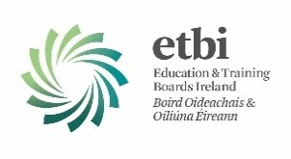
Appendix 1

ETB EXECUTIVE SELF-EVALUATION [2017]
TERMS OF REFERENCE [Version 0.1]
- Background and Context
The 16 Education and Training Boards (ETBs) were established in 2013 following the amalgamation of former Vocational Education and Training Committees (VECs) and the transfer of 13 former FÁS training centres.
The 2012 Qualifications and Quality Assurance Act 2012 sets out detailed responsibilities that apply to the ETBs for quality assuring their programmes of education and training and related services. Quality and Qualifications Ireland (QQI) published Core Statutory Quality Assurance (QA) Guidelines in April 2016 and Sector Specific Quality Assurance Guidelines for the Education and Training Boards in May 2017.¹ Since establishment in 2013 ETBs have been operating legacy quality assurance arrangements which transitioned to QQI under section 84 of the Act.
The FET Strategy 2014-2019 provides a clear policy context for quality in further education and training (FET). One of the five goals within the strategy is ‘Quality Provision - that FET will provide high quality education and training programmes and will meet national and international quality standards.’ ² ETBs are moving now to new phase of quality assurance and establishing the foundations for the development of a sectoral QA Framework that will assure quality across the sector and enable the sector to deliver on both its statutory and policy objectives for quality. This is a transformational change and developmental process; several sectoral development projects are progressing and will impact in this regard.
- Executive Self-Evaluation
It is the responsibility of each provider, i.e. ETB, to devise procedures for quality assurance and to have its own systematic processes for evaluating its own activity and for formulating plans and recommendations for its own improvement. The self-evaluation process needs to be flexible and appropriate to the provider and its stage of development. ETBs are relatively new statutory entities, within a significant transformational change process, including for structures and governance. In the context of the requirements of QQI Core and Sector Specific QA Guidelines, there is need to evaluate the effectiveness of legacy QA procedures which may no longer fit for purpose. Within the current developmental context of ETBs, this self-evaluation process is designed to:
- assist in building capacity and identify gaps within ETBs to ensure compliance with QQI statutory core and sector specific QA Guidelines
- enhance ownership of quality and quality enhancement processes
- demonstrate leadership within the ETB
- result in recommendations for improvement and priority actions for each ETB
- recognise the environment, contexts and emerging structures of the ETBs
This is an ETB executive management level self-evaluation which will be undertaken in the context of QA sectoral development projects and in accordance with these Terms of Reference.
2.1 Purpose
The purpose of the ETB executive self-evaluation process is to evaluate the governance and management of quality assurance and the effectiveness of quality assurance procedures, and to contribute to the development of an improvement plan which will support the ETB in meeting its statutory requirements for the establishment and operation of internal quality assurance procedures, recognising the developmental and transitional contexts.
- Objectives
The objectives of the ETB Executive Self-Evaluation are:
- To contribute to and support the ETB quality improvement planning and ETB ownership and governance of quality and quality enhancement.
- To promote the improvement of quality assurance and further embedding of a quality culture in the ETB.
- To support sectoral level improvement by ensuring there is a consistency in the approach to the executive self-evaluation process, thematic focus and criteria applied self-evaluation report format and improvement plan.
- To identify current gaps and priorities for improvement in the context of QQI statutory QA guidelines.
- Process and Methodology
The executive self-evaluation will be conducted with an external advisor/facilitator(s). A project lead for the executive self-evaluation process will be identified in the ETB.
The FET management team in the ETB, in collaboration with the external facilitator(s) will identify the evidence basis for the self-evaluation, and will produce the ETB executive self-evaluation report addressing the agreed objectives, criteria and terms of reference.
The final report will be agreed and signed off through the ETB Chief Executive and will form the basis of the ETB Improvement Plan.

