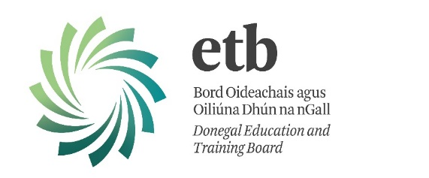
Types of courses funded by the
Community Education Support Programme

Arts, Craft & Media | Agriculture, Science & Computing
- Art  - Needlework  - Pottery  - Crafts  - Oil Painting  - Drawing  - Sewing  - Fly Tying  - Photography  - Creel Making | - Gardening  - Horticulture  - Boom Sprayer/Pesticide Application  - Beekeeping  - Hen Coop Building  - Wood Turning  - Beginners IT  - Webpage Design  - Word Processing
Core Skills, Language & General Studies | Construction & the Built Environment
- Spanish  - Basic Irish  - Conversational Irish  - French  - Communications | - Boat Building  - Men’s Shed  - Carpentry
Education, Health & Welfare | Tourism, Hospitality & Sport
- Training & Development QQI Level 6  - Personal Development  - Confidence Building and Assertiveness  - Meditation/Mindfulness  - Yoga  - Healthy Living | - Baking  - Cookery  - Bread Making  - Cookery for Men  - HACCP  - Food Hygiene
Engineering & Manufacturing | Business & Administration
- Bike Maintenance  - Practical DIY  - Electrical Maintenance  - Welding | - Bookkeeping

These are but a flavour of courses we have funded. We are happy to discuss other courses identified by groups and requested in their communities.
Further information and the Application Pack for funding are available at www.donegaletb.ie/communityeducation

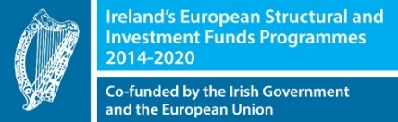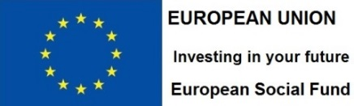

“Ireland’s European Structural and Investment Funds Programmes 2014-2020
Co-funded by the Irish Government and the European Union”.

